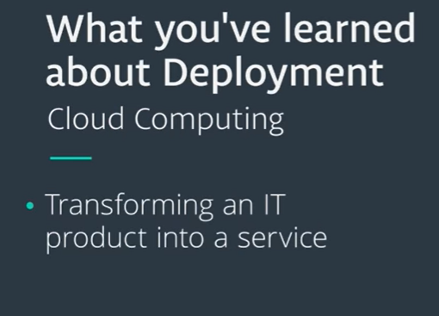

**What's Ahead?**

In this lesson, you're going to get familiar with what's meant by *machine learning deployment*. Then in the upcoming lessons, you will put these ideas to practice by using [**Amazon's SageMaker**](https://aws.amazon.com/sagemaker/). SageMaker is just *one* method for deploying machine learning models.

Specifically in this lesson, we will look at answering the following questions:

1. What's the *machine learning workflow*?
2. How does ***deployment*** fit into the *machine learning workflow*?
3. What is *cloud computing*?
4. Why would we use *cloud computing* for ***deploying*** machine learning models?
5. Why isn't ***deployment*** a part of many machine learning curriculums?
6. What does it mean for a model to be ***deployed***?
7. What are the *essential* characteristics associated with the code of *deployed models*?
8. What are *different* cloud computing platforms we might use to ***deploy*** our machine learning models?

At the end of this lesson, you'll understand the broader idea of ***machine learning deployment***. Then Sean will be guiding you through using **[SageMaker](https://aws.amazon.com/sagemaker/" \t "_blank)** to *deploy* your own machine learning models. This is a lot to cover, but by the end you will have a general idea of *all* the concepts related to *deploying machine learning models* into real world *production systems*.

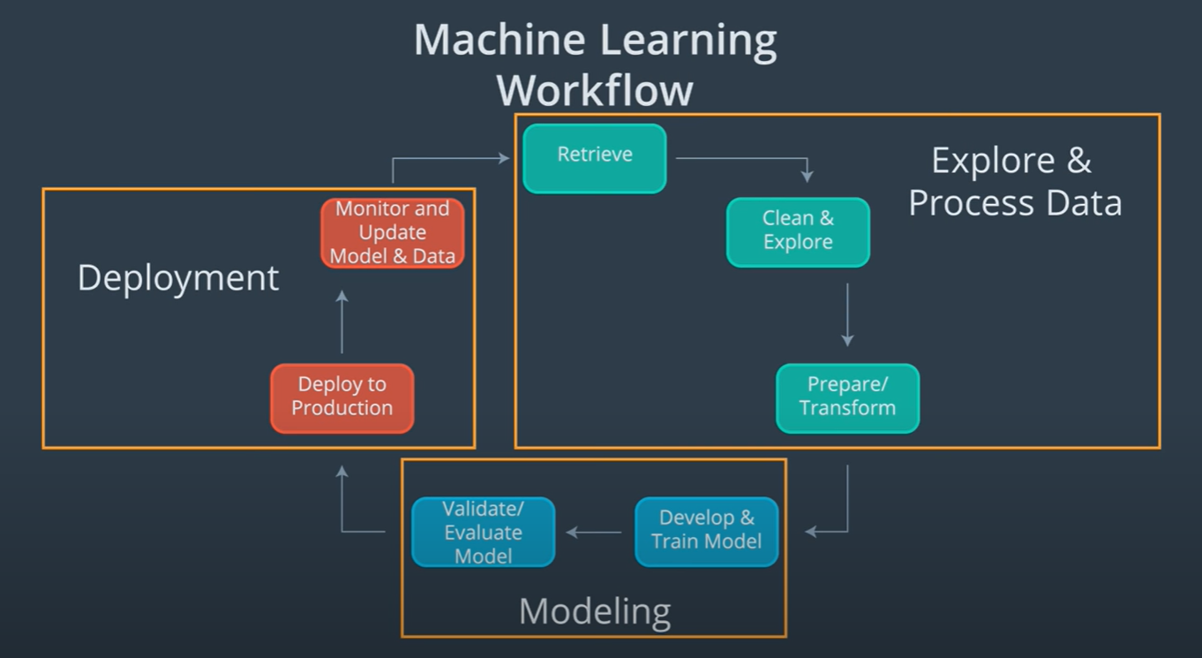

### References

Below are links that provide more detailed information on the Machine Learning Workflow that we discussed in this section above, described by cloud providers: Amazon, Google, and Microsoft.

**1.** [**Amazon Web Services**](https://aws.amazon.com/) (AWS) discusses their definition of the [**Machine Learning Workflow**](https://docs.aws.amazon.com/sagemaker/latest/dg/how-it-works-mlconcepts.html).

**2.** [**Google Cloud Platform**](https://cloud.google.com/) (GCP) discusses their definition of the [**Machine Learning Workflow**](https://cloud.google.com/ml-engine/docs/tensorflow/ml-solutions-overview).

**3.** [**Microsoft Azure**](https://azure.microsoft.com/en-us/) (Azure) discusses their definition of the [**Machine Learning Workflow**](https://docs.microsoft.com/en-us/azure/machine-learning/service/overview-what-is-azure-ml).

### Cloud Computing

In this section, we will focus on answering two questions:

* What is cloud computing?
* Why would a business decide to use cloud computing?

This section will be a high-level look. However, you can dive more into the details by looking at the optional pages added at the end of this section.

### What is cloud computing?

You can think of **cloud computing** as transforming an IT product into an IT service.

Consider the following example:

Have you ever had to backup and store important files on your computer? Maybe these files are family photos from your last vacation. You might store these photos on a flash drive. These days you have an alternative option to store these photos in the **cloud** using a cloud storage provider, like: [**Google Drive**](https://www.google.com/drive/), [**Apple’s iCloud**](https://www.apple.com/icloud/), or [**Microsoft’s OneDrive**](https://onedrive.live.com/about/en-us/).

**Cloud computing** can simply be thought of as transforming an Information Technology (IT) product into a service. With our vacation photos example, we transformed storing photos on an IT product, the **flash drive**; into storing them using a service, like **Google Drive**.

Using a cloud storage service provides the **benefits** of making it easier to access and share your vacation photos, because you no longer need the flash drive. You’ll only need a device with an internet connection to access your photos and to grant permission to others to access your photos.

Generally, think of **cloud computing** as using an internet connected device to log into a cloud computing service, like **Google Drive**, to access an IT resource, your vacation **photos**. These IT resources, your vacation **photos**, are stored in the cloud provider’s **data center**. Besides cloud storage, other cloud services include: cloud applications, databases, virtual machines, and other services like SageMaker.

### Why would a business decide to use cloud computing?

Most of the factors related to choosing cloud computing services, instead of developing on-premise IT resources are related to **time** and **cost**. The **capacity utilization** graph below shows how cloud computing compares to traditional infrastructure (on-premise IT resources) in meeting customer demand.

**Capacity** in the graph below can be thought of as the IT resources like: compute capacity, storage, and networking, that's needed to meet customer demand for a business' products and the **costs** associated with those IT resources. In our vacation photos example, customer demand is for storing and sharing customer photos. The IT resources are the required software and hardware that enables photo storage and sharing in the cloud or on-premise (traditional infrastructure).

Looking at the graph, notice that traditional infrastructure doesn't scale when there are spikes in demand, and also leaves excess when preparing for future demand. This ability to easily meet unstable, fluctuating customer demand illustrates many of the benefits of cloud computing.

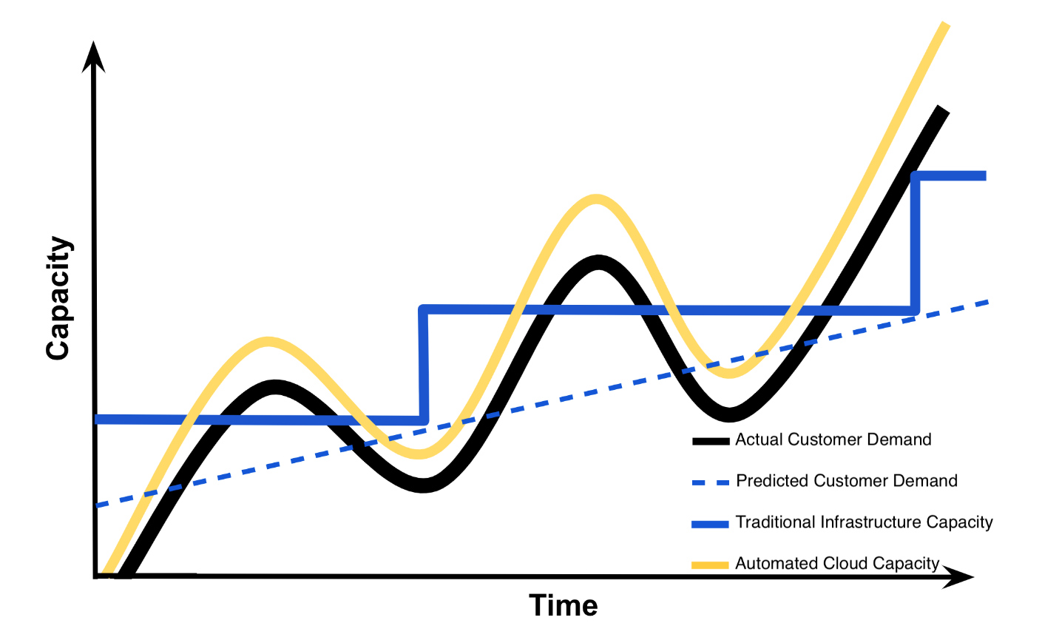

### Summary of Benefits of Risks Associated with Cloud Computing

The **capacity utilization** graph above was initially used by cloud providers like Amazon to illustrate the **benefits** of cloud computing. Summarized below are the **benefits** of cloud computing that are often what drives businesses to include cloud services in their IT infrastructure [**1**]. These same **benefits** are echoed in those provided by cloud providers Amazon ([**benefits**](https://aws.amazon.com/what-is-cloud-computing/)), Google ([**benefits**](https://cloud.google.com/what-is-cloud-computing/)), and Microsoft ([**benefits**](https://azure.microsoft.com/en-us/overview/what-is-cloud-computing/)).

#### Benefits

1. Reduced Investments and Proportional Costs (providing cost reduction)
2. Increased Scalability (providing simplified capacity planning)
3. Increased Availability and Reliability (providing organizational agility)

Below we have also summarized he **risks** associated with cloud computing [**1**]. Cloud providers don't typically highlight the risks assumed when using their cloud services like they do with the benefits, but cloud providers like: Amazon ([**security**](https://aws.amazon.com/security/introduction-to-cloud-security/)), Google ([**security**](https://cloud.google.com/security/data-safety/)), and Microsoft ([**security**](https://www.microsoft.com/en-us/TrustCenter/CloudServices/Azure/default.aspx)) often provide details on security of their cloud services. It's up to the cloud user to understand the compliance and legal issues associated with housing data within a cloud provider's data center instead of on-premise. The service level agreements (SLA) provided for a cloud service often highlight security responsibilities of the cloud provider and those assumed by the cloud user.

#### Risks

1. (Potential) Increase in Security Vulnerabilities
2. Reduced Operational Governance Control (over cloud resources)
3. Limited Portability Between Cloud Providers
4. Multi-regional Compliance and Legal Issues

#### References

**1.**   Erl, T., Mahmood, Z., & Puttini R,. (2013). Cloud Computing: Concepts, Technology, & Architecture. Upper Saddle River, NJ: Prentice Hall.

        Chapter 3: Understanding Cloud Computing provides an outline of the business drivers, benefits and risks of cloud computing.

#### Additional Resources

For the purpose of deploying machine learning models, it's important to understand the basics of cloud computing. The essentials are provided above, but if you want to learn more about the overall role of cloud computing in developing software, check out the [Optional] Cloud Computing Defined and [Optional] Cloud Computing Explained sections at the end of this lesson along with the additional resources provided below.

* [**National Institute of Standards and Technology**](https://www.nist.gov/) formal definition of [**Cloud Computing**](https://csrc.nist.gov/publications/detail/sp/800-145/final).
* Kavis, M. (2014). Architecting the Cloud: Design Decisions for Cloud Computing Service Models. Hoboken, NJ: Wiley. Chapter 3 provides the worst practices of cloud computing which highlights both risks and benefits of cloud computing. Chapter 9 provides the security responsibilities by service model.
* [**Amazon Web Services**](https://aws.amazon.com/) (AWS) discusses their definition of [**Cloud Computing**](https://aws.amazon.com/what-is-cloud-computing/).
* [**Google Cloud Platform**](https://cloud.google.com/) (GCP) discusses their definition of [**Cloud Computing**](https://cloud.google.com/what-is-cloud-computing/).
* [**Microsoft Azure**](https://azure.microsoft.com/en-us/) (Azure) discusses their definition of [**Cloud Computing**](https://azure.microsoft.com/en-us/overview/what-is-cloud-computing/).

NEXT

#### Notes:

All algorithms used within the machine learning workflow are similar for both the cloud and on-premise computing. The only real difference may be in the user interface and libraries that will be used to execute the machine learning workflow.

For **personal use**, one’s likely to use cloud services, if they don’t have enough computing capacity.

With **academic use**, quite often one will use the university’s on-premise computing resources, given their availability. For smaller universities or research groups with few funding resources, cloud services might offer a viable alternative to university computing resources.

For **workplace usage**, the amount of cloud resources used depends upon an organization’s existing infrastructure and their vulnerability to the risks of cloud computing. A workplace may have security concerns, operational governance concerns, and/or compliance and legal concerns regarding cloud usage. Additionally, a workplace may already have on-premise infrastructure that supports the workflow; therefore, making cloud usage an unnecessary expenditure. Keep in mind, many progressive companies may be incorporating cloud computing into their business due to the business drivers and benefits of cloud computing.

### Deployment to Production

##### Recall that:

**Deployment to production** can simply be thought of as a method that integrates a machine learning model into an existing production environment so that the model can be used to make decisions or predictions based upon data input into the model.

This means that moving from modeling to deployment, a model needs to be provided to those responsible for deployment. We are going to assume that the machine learning model we will be deploying was developed in Python.

### Paths to Deployment

There are three primary methods used to transfer a model from the **modeling** component to the **deployment** component of the machine learning workflow. We will be discussing them in order of **least** to **most** commonly used. The **third** method that's most similar to what’s used for deployment within **Amazon’s SageMaker**.

#### Paths to Deployment:

1. Python model is recoded into the programming language of the production environment.
2. Model is coded in Predictive Model Markup Language (PMML) or Portable Format Analytics (PFA).
3. Python model is converted into a format that can be used in the production environment.

#### Recoding Model into Programming Language of Production Environment

The first method which involves recoding the Python model into the language of the production environment, often Java or C++. This method is rarely used anymore because it takes time to recode, test, and validate the model that provides the same predictions as the original.

#### Model is Coded in PMML or PFA

The second method is to code the model in Predictive Model Markup Language (PMML) or Portable Format for Analytics (PFA), which are two complementary standards that simplify moving predictive models to deployment into a production environment. The Data Mining Group developed both PMML and PFA to provide vendor-neutral executable model specifications for certain predictive models used by data mining and machine learning. Certain analytic software allows for the direct import of PMML including but not limited to IBM SPSS, R, SAS Base & Enterprise Miner, Apache Spark, Teradata Warehouse Miner, and TIBCO Spotfire.

#### Model is Converted into Format that’s used in the Production Environment

The third method is to build a Python model and **use** libraries and methods that convert the model into **code** that can be used in the production environment. Specifically most popular machine learning software frameworks, like PyTorch, TensorFlow, SciKit-Learn, have methods that will convert Python models into intermediate standard format, like ONNX ([**Open Neural Network Exchange**](https://onnx.ai/) format). This intermediate standard format then can be **converted** into the software native to the production environment.

* This is the easiest and fastest way **to move** a Python model from modeling directly to deployment.
* Moving forward this is typically the way models are **moved** into the production environment.
* Technologies like containers, endpoints, and APIs (Application Programming Interfaces) also help **ease** the **work** required for deploying a model into the production environment.

We will discuss these technologies in more detail in the **next** sections.

### Machine Learning Workflow and DevOps

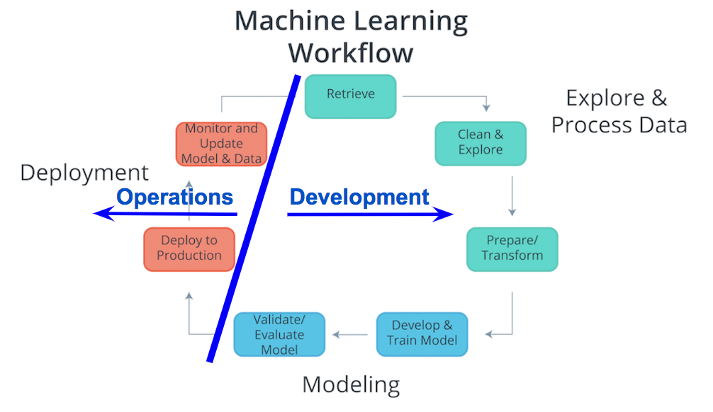

#### Machine Learning Workflow and Deployment

Considering the components of the Machine Learning Workflow, one can see how Exploring and Processing Data is tightly coupled with Modeling. The modeling **can’t** occur without first having the data the model will be based upon prepared for the modeling process.

Comparatively deployment is **more** tightly coupled with the production environment than with modeling or exploring and processing the data. Therefore, traditionally there’s was a separation between Deployment and the other components of the machine learning workflow. Specifically looking at the diagram **above**, the **Process Data and Modeling** are considered **Development**; whereas, **Deployment** is typically considered **Operations**.

In the past typically, **development** was handled by **analysts**; whereas, **operations** was handled by **software developers** responsible for the production environment. With recent developments in technology (containers, endpoints, APIs) and the most common path of deployment; this division between **development** and **operations** softens. The softening of this division enables **analysts** to handle certain aspects of **deployment** and enables faster updates to faltering models.

#### Deployment within Machine Learning Curriculum

**Deployment** is **not** commonly included in machine learning curriculum. This likely is associated with the analyst's typical focus on **Exploring and Processing Data** and **Modeling**, and the software developer's focusing more on **Deployment** and the production environment. Advances in cloud services, like **[SageMaker](https://aws.amazon.com/sagemaker/" \t "_blank)** and [**ML Engine**](https://cloud.google.com/ml-engine/), and deployment technologies, like Containers and REST APIs, allow for analysts to easily take on the responsibilities of **deployment**.

NEXT

**Production Environment and the Endpoint**

When we discussed the *production environment*, the ***endpoint*** was defined as the **interface** to the model. This **interface** (***endpoint***) facilitates an ease of communication between the *model* and the *application*. Specifically, this **interface** (***endpoint***)

* Allows the *application* to send ***user data*** to the *model* and
* Receives ***predictions*** back from the *model* based upon that ***user data***.

**Model, Application, and Endpoint**

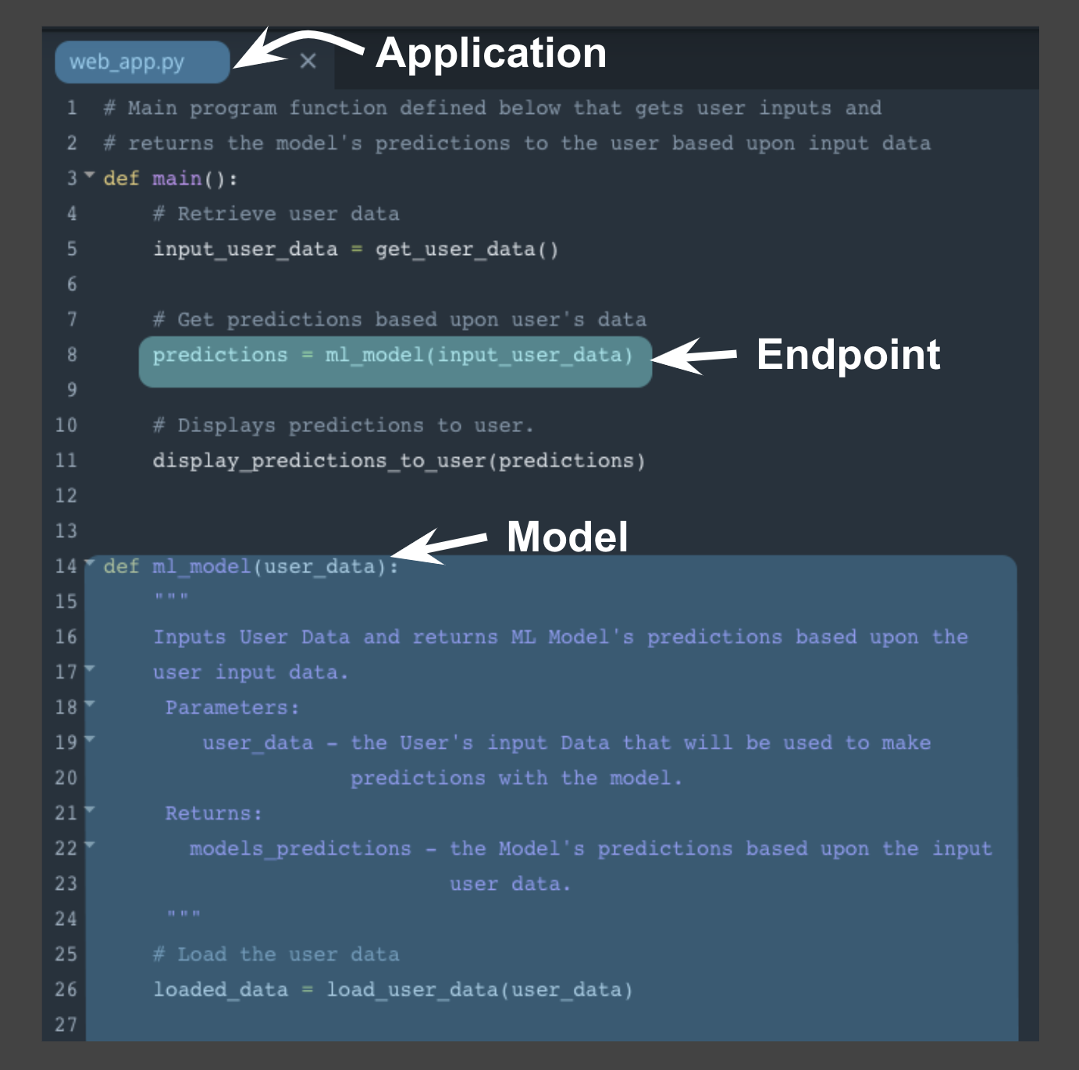

One way to think of the ***endpoint*** that acts as this *interface*, is to think of a *Python program* where:

* the **endpoint** itself is like a ***function call***
* the ***function*** itself would be the **model** and
* the ***Python program*** is the **application**.

The image **above** depicts the association between a ***Python program*** and the **endpoint**, **model**, and **application**.

* the **endpoint**: *line* ***8*** ***function call*** to **ml\_model**
* the **model**: beginning on *line* ***14*** ***function definition*** for **ml\_model**
* the **application**: ***Python program*** **web\_app.py**

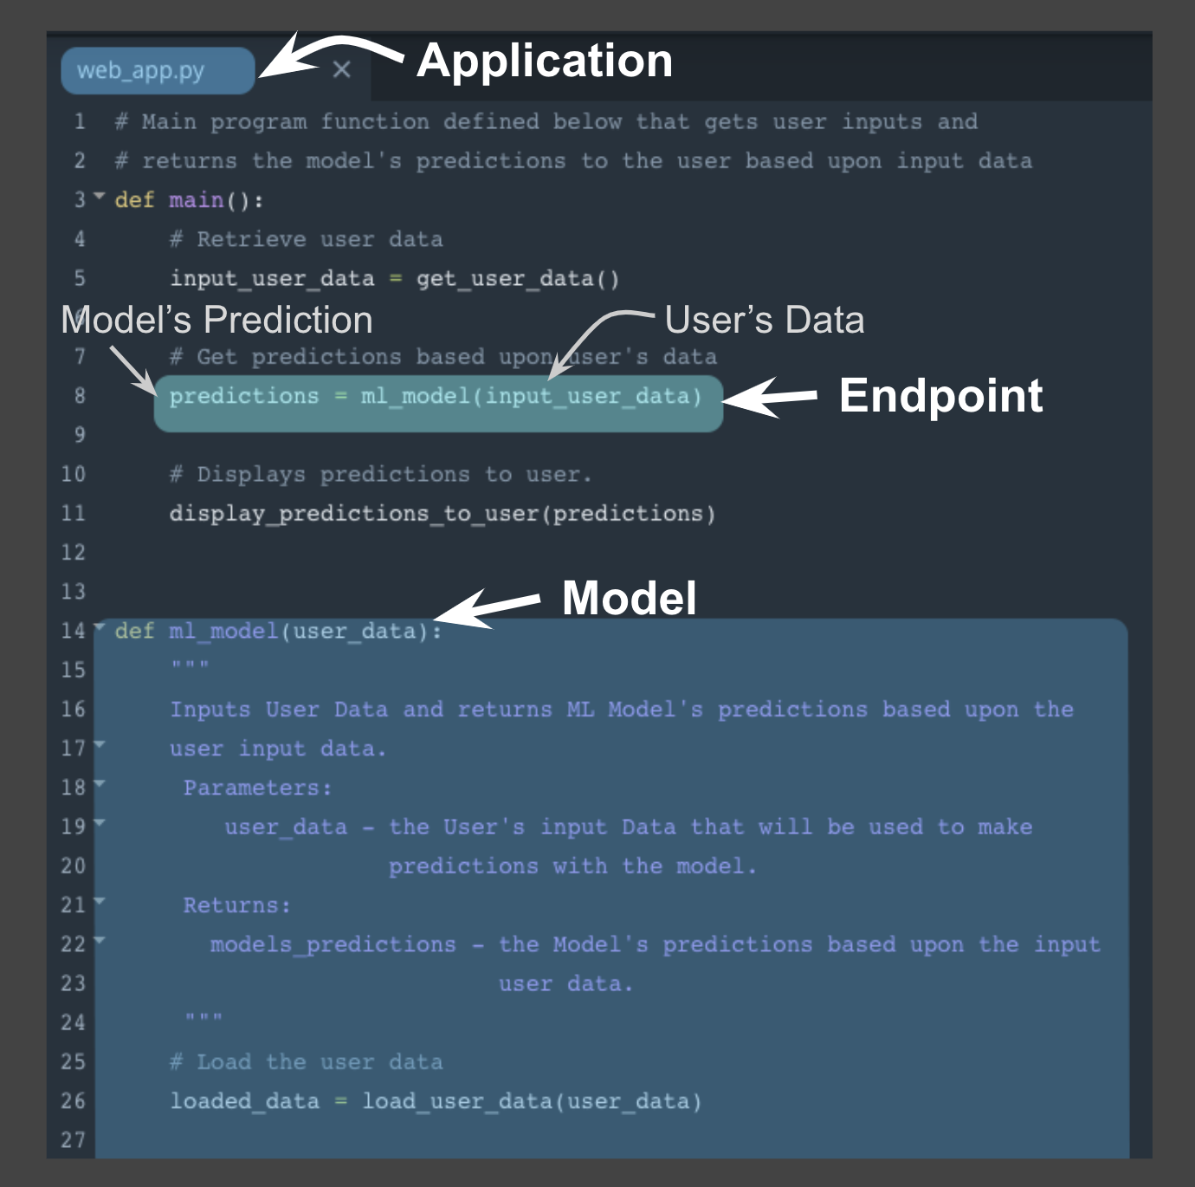

Using this example **above** notice the following:

* *Similar* to a ***function call*** the **endpoint** accepts *user data* as the ***input*** and ***returns*** the *model’s prediction* based upon this ***input*** through the **endpoint**.
* In the example, the *user data* is the ***input argument*** and the *prediction* is the ***returned value*** from the ***function call***.
* The **application**, here the ***python program***, displays the *model’s prediction* to the *application user*.

This example highlights how the **endpoint** itself is just the ***interface*** between the **model** and the **application**; where this ***interface*** enables users to get *predictions* from the ***deployed*** *model* based on their *user data*.

Next we'll focus on *how* the **endpoint** (***interface***) facilitates communication between **application** and **model**.

**Endpoint and REST API**

Communication between the **application** and the **model** is done through the **endpoint** (***interface***), where the **endpoint** is an **Application Programming Interface** (**API**).

* An *easy* way to think of an **API**, is as a *set of rules* that *enable* programs, here the **application** and the **model**, to *communicate* with each other.
* In this case, our **API** uses a **RE**presentational **S**tate **T**ransfer, **REST**, architecture that provides a framework for the *set of rules* and *constraints* that must be adhered to for *communication* between programs.
* This **REST API** is one that uses *HTTP requests* and *responses* to enable communication between the **application** and the **model** through the **endpoint** (***interface***).
* Noting that ***both*** the **HTTP request** and **HTTP response** are *communications* sent between the **application** and **model**.

The **HTTP request** that’s sent from your **application** to your **model** is composed of *four* parts:

* **Endpoint**
  + This **endpoint** will be in the form of a URL, Uniform Resource Locator, which is commonly known as a web address.
* HTTP Method
  + Below you will find four of the **HTTP methods**, but for purposes of ***deployment*** our **application** will use the ***POST method*** *only*.
* HTTP Headers
  + The **headers** will contain additional information, like the format of the data within the message, that’s passed to the *receiving* program.
* Message (Data or Body)
  + The final part is the **message** (data or body); for ***deployment*** will contain the *user’s data* which is input into the **model**.

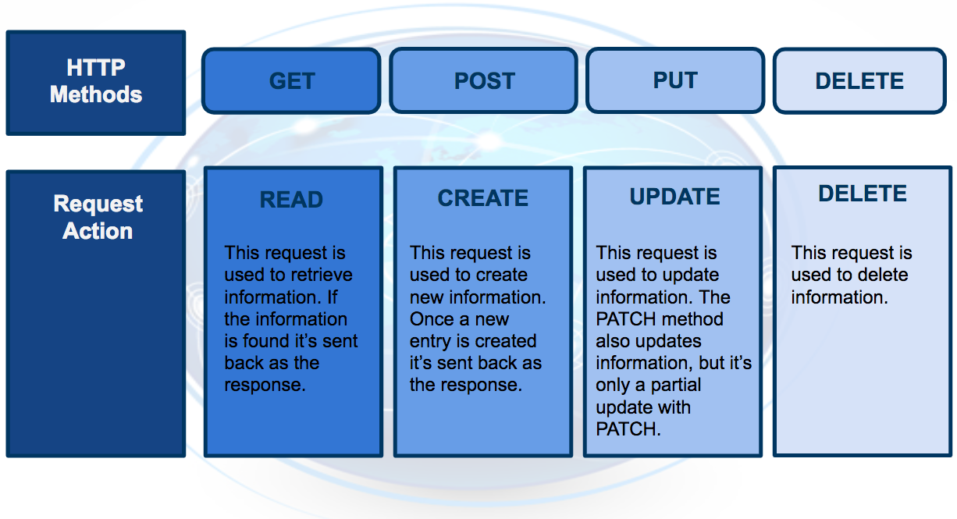

The **HTTP response** sent from your model to your application is composed of *three* parts:

* HTTP Status Code
  + If the model successfully received and processed the *user’s data* that was sent in the **message**, the status code should start with a ***2***, like *200*.
* HTTP Headers
  + The **headers** will contain additional information, like the format of the data within the **message**, that’s passed to the receiving program.
* Message (Data or Body)
  + What’s returned as the *data* within the **message** is the *prediction* that’s provided by the **model**.

This *prediction* is then presented to the *application user* through the **application**. The **endpoint** is the ***interface*** that *enables communication* between the **application** and the **model** using a **REST API**.

As we learn more about **REST*ful*API**, realize that it's the **application’s** responsibility:

* To format the *user’s data* in a way that can be easily put into the **HTTP request** ***message*** and ***used*** by the **model**.
* To translate the *predictions* from the **HTTP response** ***message*** in a way that’s easy for the *application user’s* to understand.

Notice the following regarding the *information* included in the ***HTTP messages*** sent between **application** and **model**:

* Often *user's data* will need to be in a *CSV* or *JSON* format with a specific *ordering* of the data that's dependent upon the **model** used.
* Often *predictions* will be returned in *CSV* or *JSON* format with a specific *ordering* of the returned *predictions* dependent upon the **model** used.

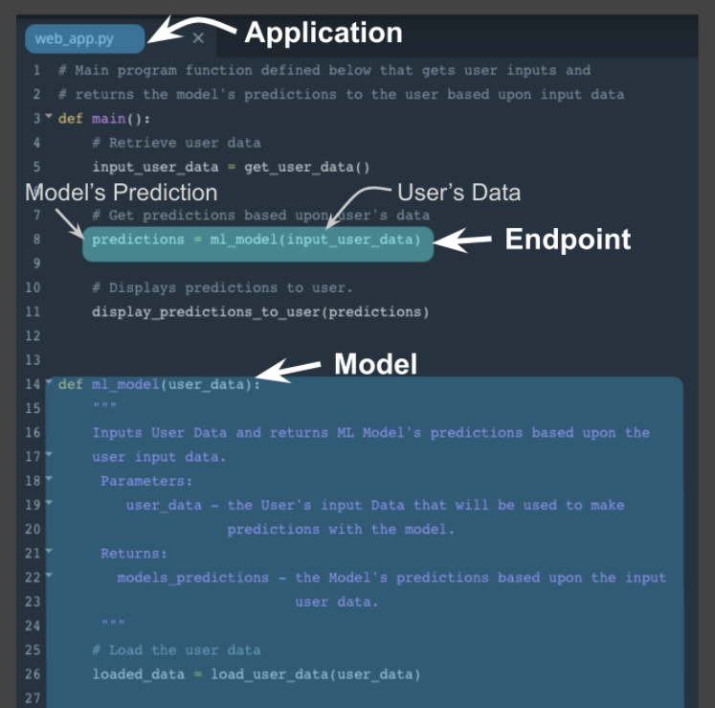

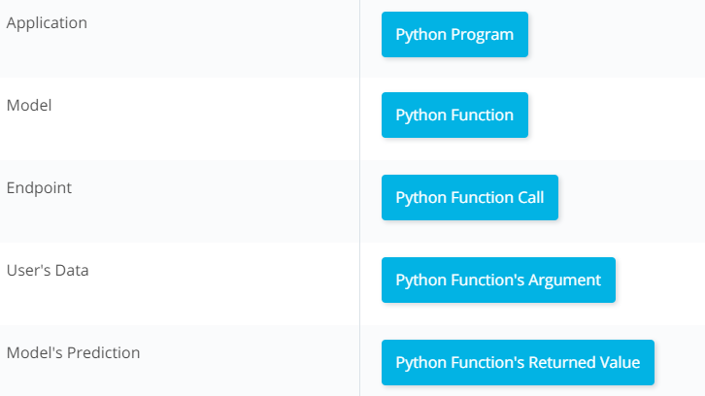

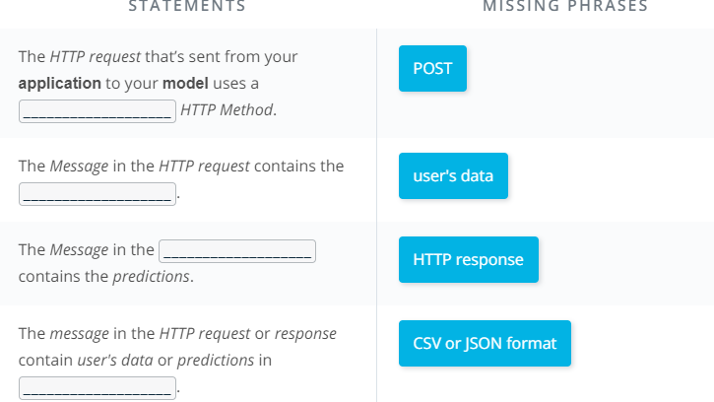

### Containers

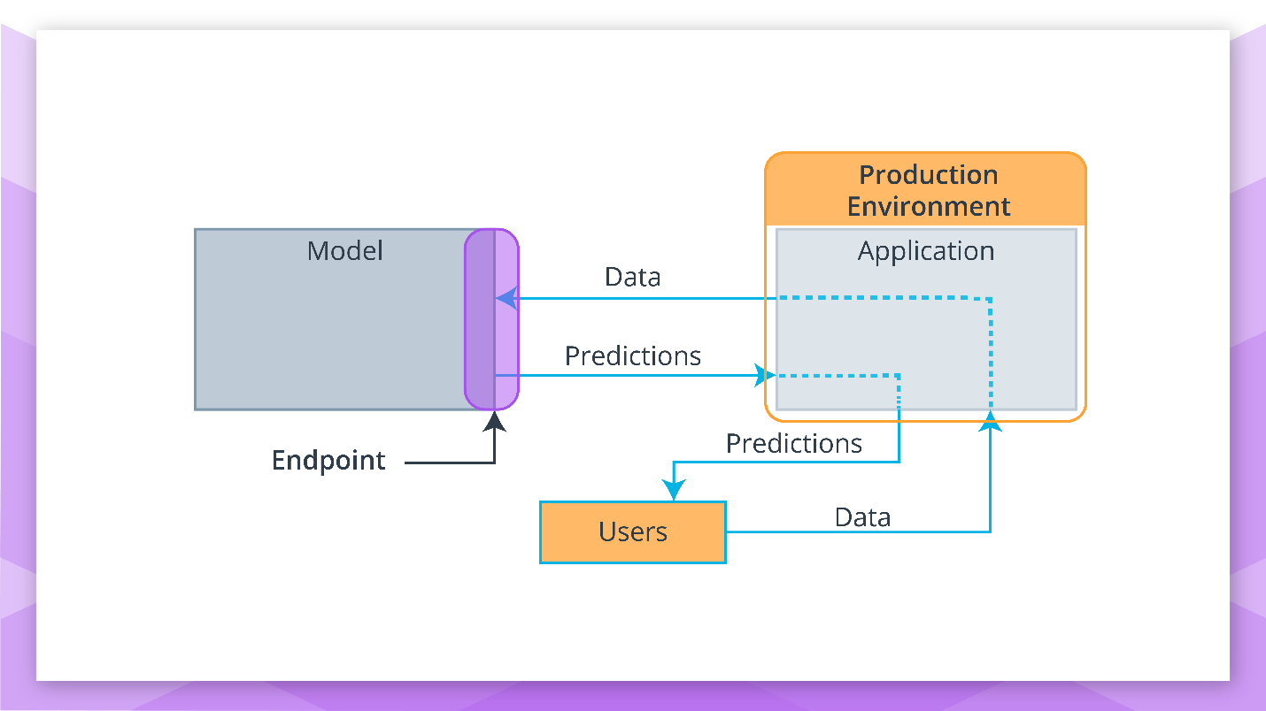

### Model, Application, and Containers

When we discussed the production environment, it was composed of two primary programs, the **model** and the **application**, that communicate with each other through the **endpoint** (**interface**).

* The **model** is simply the Python model that's created, trained, and evaluated in the **Modeling** component of the machine learning workflow.
* The **application** is simply a web or software application that enables the application users to use the model to retrieve predictions.

Both the **model** and the **application** require a computing environment so that they can be run and available for use. One way to create and maintain these computing environments is through the use of **containers**.

* Specifically, the **model** and the **application** can each be run in a **container** computing environment. The **containers** are created using a **script** that contains instructions on which software packages, libraries, and other computing attributes are needed in order to run a software application, in our case either the **model** or the **application**.

#### Containers Defined

* A **container** can be thought of as a standardized collection/bundle of software that is to be used for the specific purpose of running an application.

As stated **above** **container** technology is used to create the **model** and **application** computational environments associated with **deployment** in machine learning. A common **container** software is Docker. Due to its popularity sometimes Docker is used synonymously with **containers**.

#### Containers Explained

Often to first explain the concept of **containers**, people tend to use the analogy of how Docker containers are similar to shipping containers.

* Shipping containers can contain a wide variety of products, from food to computers to cars.
* The structure of a shipping container provides the ability for it to hold different types of products while making it easy to track, load, unload, and transport products worldwide within a shipping container.

Similarly Docker **containers**:

* Can contain **all** types of different software.
* The structure of a Docker **container** enables the **container** to be created, saved, used, and deleted through a set of common tools.
* The common tool set works with **any** **container** regardless of the software the **container** contains.

#### Container Structure

The image **below** shows the basic structure of a **container**, you have:

* The underlying computational infrastructure which can be: a cloud provider’s data center, an on-premise data center, or even someone’s local computer.
* Next, you have an operating system running on this computational infrastructure, this could be the operating system on your local computer.
* Next, there’s the container engine, this could be Docker software running on your local computer. The container engine software enables one to create, save, use, and delete containers; for our example, it could be Docker running on a local computer.
* The final two layers make up the composition of the containers.
  + The first layer of the container is the libraries and binaries required to launch, run, and maintain the next layer, the application layer.
* The image **below** shows three containers running three different applications.

This architecture of **containers** provides the following advantages:

1. Isolates the application, which increases security.
2. Requires only software needed to run the application, which uses computational resources more efficiently and allows for faster application deployment.
3. Makes application creation, replication, deletion, and maintenance easier and the same across all applications that are deployed using containers.
4. Provides a more simple and secure way to replicate, save, and share containers.

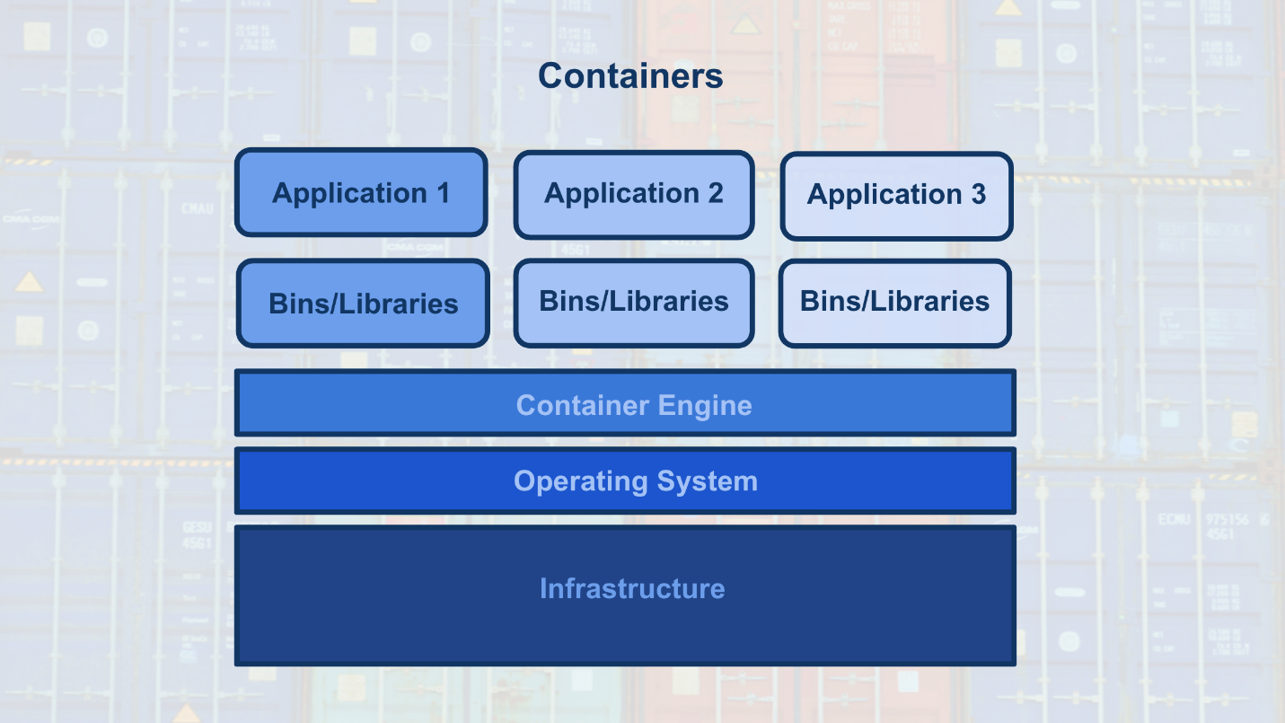

As indicated by the **fourth** advantage of using **containers**, a **container** script file is used to create a **container**.

* This text script file can easily be shared with others and provides a simple method to replicate a particular **container**.
* This **container** script is simply the instructions (algorithm) that is used to create a **container**; for Docker these **container** scripts are referred to as dockerfiles.

This is shown with the image **below**, where the container engine uses a **container** script to create a **container** for an application to run within. These **container** script files can be stored in repositories, which provide a simple means to share and replicate containers. For Docker, the [**Docker Hub**](https://hub.docker.com/explore/) is the official repository for storing and sharing dockerfiles. Here's an example of a **[dockerfile](https://github.com/pytorch/pytorch/blob/master/docker/pytorch/Dockerfile" \t "_blank)** that creates a docker container with Python 3.6 and PyTorch installed.

### Expert Interview on Containers

We will be talking with Jesse Swidler, a senior software engineer at Udacity, to learn more about **containers**. He will tell us more about what they are, what they do, and how they make his job easier. He'll even describe how we **use** **containers** when we work within a **Workspace**.

When you work on exercises and projects within a Nanodegree, often you will work within a **Workspace** environment within the classroom. Below you will find an image of a **Workspace** environment that contains a Jupyter notebook. The **Workspace** environment makes use of containers so that you can run PyTorch, Numpy, Pandas, without having to install those Python packages.

#### Example Workspace

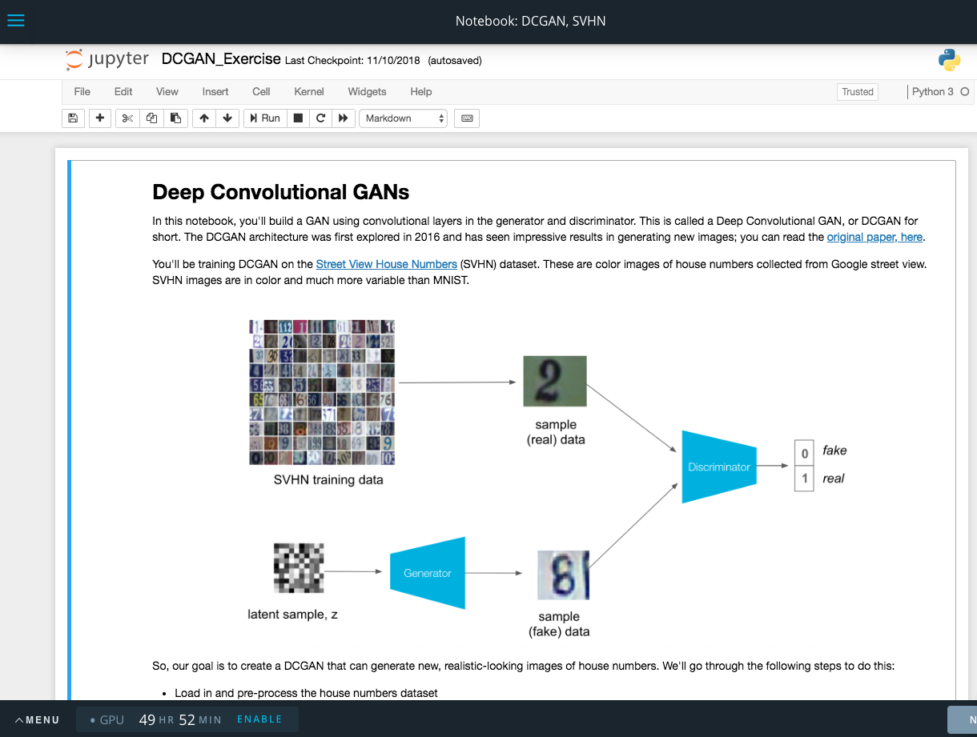

Jupyter Notebook within the Workspace Environment

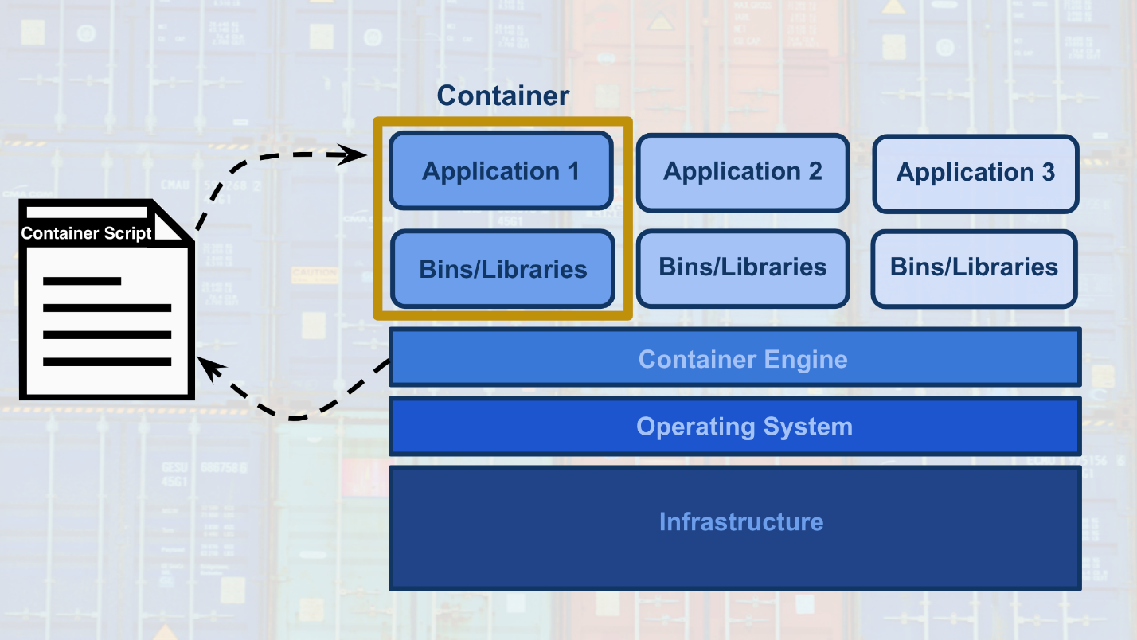

## Characteristics of Deployment and Modeling

##### Recall that:

**Deployment** to production can simply be thought of as a method that integrates a machine learning **model** into an existing **production environment** so that the **model** can be used to make decisions or predictions based upon data input into this **model**.

Also remember that a **production environment** can be thought of as a web, mobile, or other software **application** that is currently being used by many people and must respond quickly to those users’ requests.

Keeping these things in mind, there are a number of characteristics of **deployment** and **modeling** that I’m going to introduce here. These concepts are introduced now to provide you with familiarity with these concepts for when you see them discussed in future lessons. Specifically, these concepts are provided as **features** that are made easier to use within cloud platforms services than if implemented with your own code.

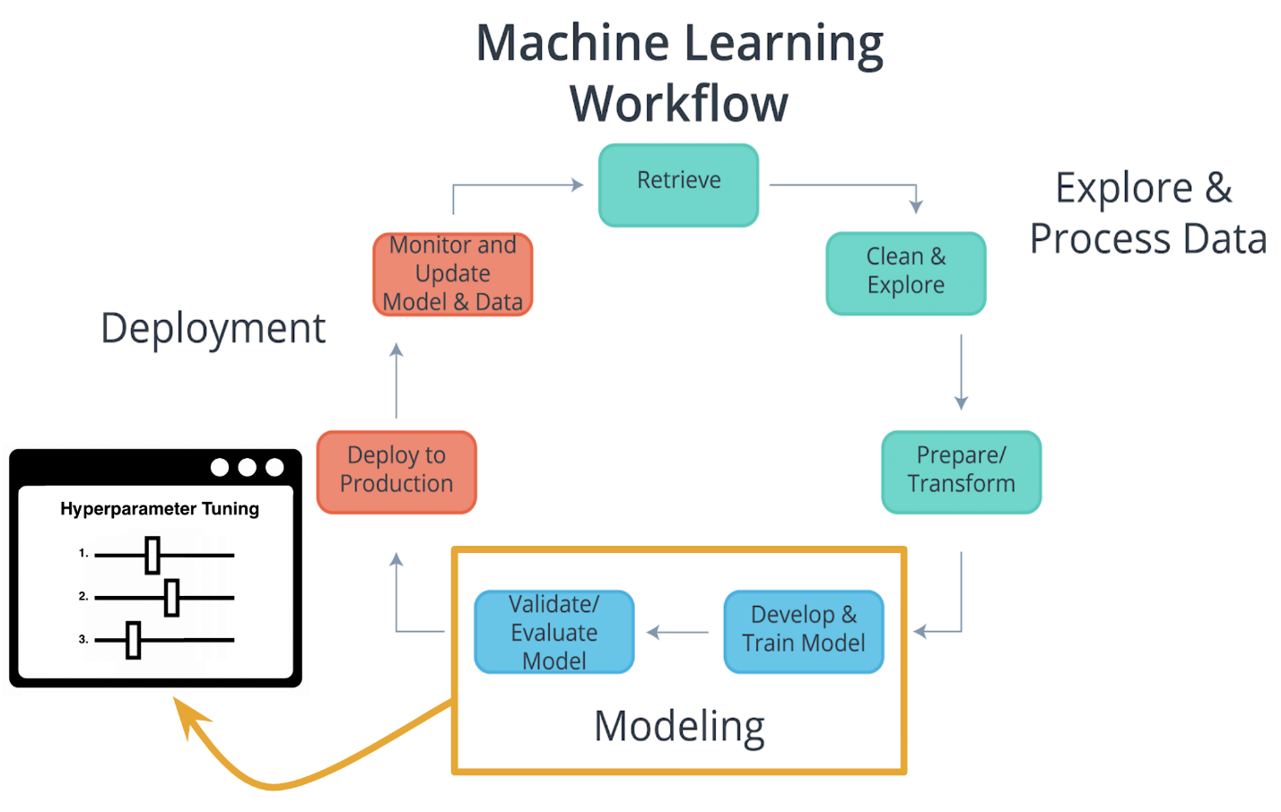

### Characteristics of Modeling

#### Hyperparameters

In machine learning, a **hyperparameter** is a parameter whose value cannot be estimated from the data.

* Specifically, a **hyperparameter** is not directly learned through the estimators; therefore, their value must be set by the model developer.
* This means that **hyperparameter** tuning for optimization is an **important part** of model training.
* Often cloud platform machine learning services provide methods that allow for **automatic** **hyperparameter** tuning for use with model training.

If the machine learning platform fails to offer an automatic **hyperparameter** option, one option is to use methods from [**scikit-learn**](https://scikit-learn.org/stable/) Python library for **hyperparameter** tuning. [**Scikit-learn**](https://scikit-learn.org/stable/) is a free machine learning Python library that includes methods that help with [**hyperparameter tuning**](https://scikit-learn.org/stable/modules/grid_search.html).

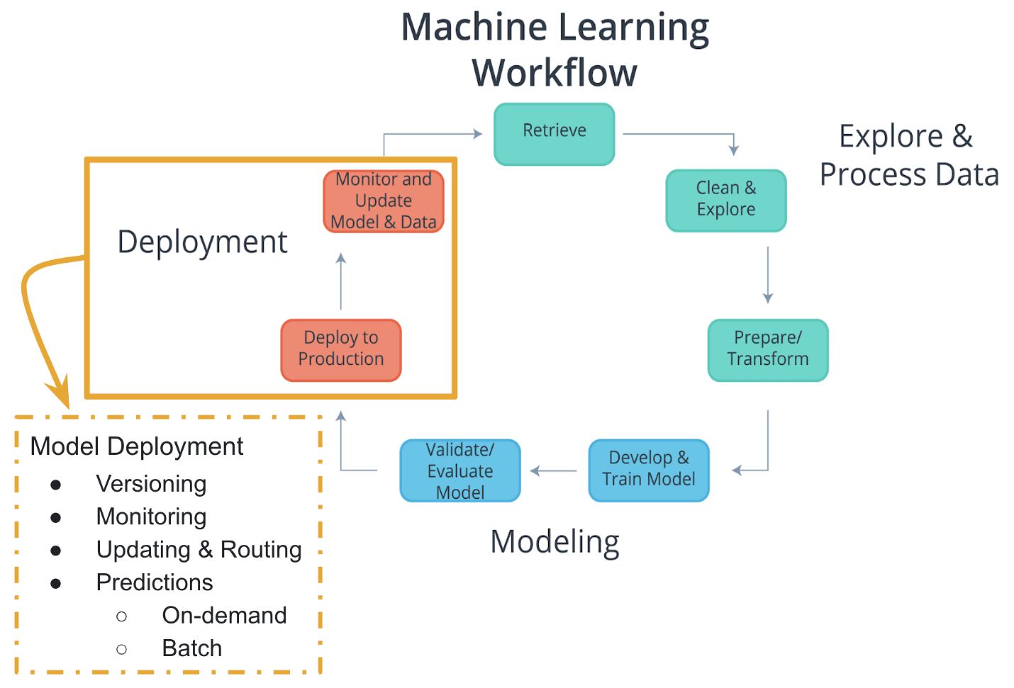

### Characteristics of Deployment

#### Model Versioning

One characteristic of deployment is the **version** of the model that is to be deployed.

* Besides saving the **model version** as a part of a model’s metadata in a database, the deployment platform should allow one to indicate a deployed **model’s version**.

This will make it easier to maintain, monitor, and update the deployed model.

#### Model Monitoring

Another characteristic of deployment is the ability to easily **monitor** your deployed models.

* Once a model is deployed you will want to make certain it continues to meet its performance metrics; otherwise, the application may need to be updated with a better performing model.

#### Model Updating and Routing

The ability to easily **update** your deployed model is another characteristic of deployment.

* If a deployed model is failing to meet its performance metrics, it's likely you will need to **update** this model.

If there's been a fundamental change in the data that’s being input into the model for predictions; you'll want to **collect** this input data to be used to **update** the model.

* The deployment platform should support **routing** differing proportions of user requests to the deployed models; to allow comparison of performance between the deployed model variants.

**Routing** in this way allows for a test of a model performance as compared to other model variants.

#### Model Predictions

Another characteristic of deployment is the type of **predictions** provided by your deployed model. There are two common types of **predictions**:

* **On-demand predictions**
* **Batch predictions**

#### On-Demand Predictions

* **On-demand predictions** might also be called:
  + online,
  + real-time, or
  + synchronous predictions
* With these type of predictions, one expects:
  + a low latency of response to each prediction request,
  + but allows for possibility high variability in request volume.
* Predictions are returned in the response from the request. Often these requests and responses are done through an API using JSON or XML formatted strings.
* Each prediction request from the user can contain one or many requests for predictions. Noting that many is limited based upon the size of the data sent as the request. Common cloud platforms **on-demand prediction** request size limits can range from 1.5(ML Engine) to 5 Megabytes (SageMaker).

**On-demand predictions** are commonly used to provide customers, users, or employees with real-time, online responses based upon a deployed model. Thinking back on our magic eight ball web application example, users of our web application would be making **on-demand prediction** requests.

#### Batch Predictions

* **Batch predictions** might also be called:
  + asynchronous, or
  + batch-based predictions.
* With these type of predictions, one expects:
  + high volume of requests with more periodic submissions
  + so latency won’t be an issue.
* Each batch request will point to specifically formatted data file of requests and will return the predictions to a file. Cloud services **require** these files will be stored in the cloud provider’s cloud.
* Cloud services typically have limits to how much data they can process with each batch request based upon limits they impose on the size of file you can store in their cloud storage service. For example, Amazon’s SageMaker limits batch predictions requests to the size limit they enforce on an object in their S3 storage service.

**Batch predictions** are commonly used to help make business decisions. For example, imagine a business uses a complex model to predict customer satisfaction across a number of their products and they need these estimates for a weekly report. This would require processing customer data through a **batch prediction** request on a weekly basis.

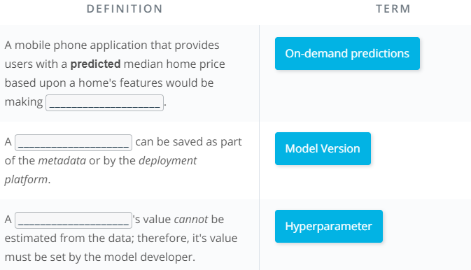

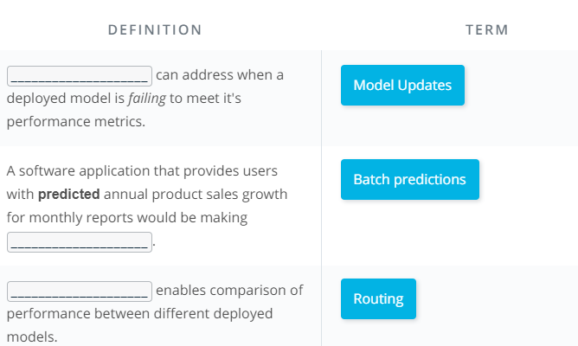

## Machine Learning Cloud Platforms

There are a number of machine learning cloud platforms, we provide more details about a few **below**. In the next few lessons, you will learn how to use **Amazon's SageMaker** to deploy machine learning models. Therefore, we focused on providing more information on [**Amazon's SageMaker**](https://aws.amazon.com/sagemaker/). To allow for a comparison of features offered by **[SageMaker](https://aws.amazon.com/sagemaker/" \t "_blank)**, we also provide detailed information about [**Google's ML Engine**](https://cloud.google.com/ml-engine/) because it's most similar to **SageMaker**.

## Amazon Web Services (AWS)

[**Amazon Web Services (AWS) SageMaker**](https://aws.amazon.com/sagemaker/) is Amazon's cloud service that allows you to build, train, and deploy machine learning models. Some advantages to using Amazon's SageMaker service are the following:

* **Flexibility in Machine Learning Software**: **[SageMaker](https://aws.amazon.com/sagemaker/" \t "_blank)** has the flexibility to enable the use of **any** programming language or software framework for building, training, and deploying machine learning models in **AWS**. For the details see the three methods of modeling within **SageMaker** **below**.
  + [**Built-in Algorithms**](https://docs.aws.amazon.com/sagemaker/latest/dg/algos.html) - There are at least fifteen built-in algorithms that are easily used within SageMaker. Specifically, built-in algorithms for discrete classification or quantitative analysis using [**linear learner**](https://docs.aws.amazon.com/sagemaker/latest/dg/linear-learner.html) or **[XGBoost](https://docs.aws.amazon.com/sagemaker/latest/dg/xgboost.html" \t "_blank)**, item recommendations using [**factorization machine**](https://docs.aws.amazon.com/sagemaker/latest/dg/fact-machines.html), grouping based upon attributes using [**K-Means**](https://docs.aws.amazon.com/sagemaker/latest/dg/k-means.html), an algorithm for [**image classification**](https://docs.aws.amazon.com/sagemaker/latest/dg/image-classification.html), and many other algorithms.
  + **Custom Algorithms** - There are different programming languages and software frameworks that can be used to develop custom algorithms which include: **[PyTorch](https://docs.aws.amazon.com/sagemaker/latest/dg/pytorch.html" \t "_blank)**, [**TensorFlow**](https://docs.aws.amazon.com/sagemaker/latest/dg/tf.html), [**Apache MXNet**](https://docs.aws.amazon.com/sagemaker/latest/dg/mxnet.html), [**Apache Spark**](https://docs.aws.amazon.com/sagemaker/latest/dg/apache-spark.html), and [**Chainer**](https://docs.aws.amazon.com/sagemaker/latest/dg/chainer.html).
  + [**Your Own Algorithms**](https://docs.aws.amazon.com/sagemaker/latest/dg/your-algorithms.html) - Regardless of the programming language or software framework, you can use your own algorithm when it **isn't** included within the built-in or custom algorithms **above**.
* **Ability to Explore and Process Data within SageMaker**: **[SageMaker](https://aws.amazon.com/sagemaker/" \t "_blank)** enables the use of **[Jupyter Notebooks](https://docs.aws.amazon.com/sagemaker/latest/dg/nbi.html" \t "_blank)** to explore and process data, along with creation, training, validation, testing, and deployment of machine learning models. This notebook interface makes data exploration and documentation easier.
* **Flexibility in Modeling and Deployment**: **[SageMaker](https://aws.amazon.com/sagemaker/" \t "_blank)** provides a number of features and automated tools that make **modeling** and **deployment** easier. For the details on these features within **SageMaker** see **below**.
  + [**Automatic Model Tuning**](https://docs.aws.amazon.com/sagemaker/latest/dg/automatic-model-tuning.html): **[SageMaker](https://aws.amazon.com/sagemaker/" \t "_blank)** provides a feature that allows hyperparameter tuning to find the **best** version of the model for built-in and custom algorithms. For built-in algorithms **SageMaker** also provides evaluation metrics to evaluate the performance of your models.
  + [**Monitoring Models**](https://docs.aws.amazon.com/sagemaker/latest/dg/monitoring-overview.html): **[SageMaker](https://aws.amazon.com/sagemaker/" \t "_blank)** provides features that allow you to monitor your deployed models. Additionally with model deployment, one can choose how much traffic to route to each deployed model (model variant). More information on routing traffic to model variants can be found [**here**](https://docs.aws.amazon.com/sagemaker/latest/dg/API_ProductionVariant.html) and [**here**](https://docs.aws.amazon.com/sagemaker/latest/dg/API_CreateEndpointConfig.html) .
  + **Type of Predictions**: **[SageMaker](https://aws.amazon.com/sagemaker/" \t "_blank)** by default allows for [**On-demand**](https://docs.aws.amazon.com/sagemaker/latest/dg/ex1-test-model.html) type of predictions where each prediction request can contain one to many requests. **SageMaker** also allows for [**Batch**](https://docs.aws.amazon.com/sagemaker/latest/dg/how-it-works-batch.html) predictions, and request data size limits are based upon S3 object size limits.

## Google Cloud Platform (GCP)

[**Google Cloud Platform (GCP) ML Engine**](https://cloud.google.com/ml-engine/) is Google's cloud service that allows you to build, train, and deploy machine learning models. Below we have highlighted some of the **similarities** and **differences** between these two cloud service platforms.

* **Prediction Costs**: The **primary difference** between the two is how they handle predictions. With **SageMaker** predictions, you must leave resources running to provide predictions. This enables less latency in providing predictions at the cost of paying for running idle services, if there are no (or few) prediction requests made while services are running. With **ML Engine** predictions, one has the option to not leave resources running which reduces cost associated with infrequent or periodic requests. Using this has more latency associated with predictions because the resources are in a offline state until they receive a prediction request. The increased latency is associated to bringing resources back online, but one only pays for the time the resources are in use. To see more about [**ML Engine pricing**](https://cloud.google.com/ml-engine/docs/pricing#node-hour) and **[SageMaker pricing](https://cloud.google.com/ml-engine/docs/pricing" \l "node-hour" \t "_blank)**.
* **Ability to Explore and Process Data**: Another **difference** between **ML Engine** and **SageMaker** is the fact that Jupyter Notebooks are not available within **ML Engine**. To use Jupyter Notebooks within **Google's Cloud Platform** (GCP), one would use **[Datalab](https://cloud.google.com/datalab/docs/" \t "_blank)**. **GCP** separates data exploration, processing, and transformation into other services. Specifically, [**Google's Datalab**](https://cloud.google.com/datalab/docs/) can be used for data exploration and data processing, **[Dataprep](https://cloud.google.com/dataprep/docs/" \t "_blank)** can be used to explore and transform raw data into clean data for analysis and processing, and **[DataFlow](https://cloud.google.com/dataflow/docs/" \t "_blank)** can be used to deploy batch and streaming data processing pipelines. Noting that **Amazon Web Services** (AWS), also have data processing and transformation pipeline services like [**AWS Glue**](https://aws.amazon.com/glue/) and [**AWS Data Pipeline**](https://aws.amazon.com/datapipeline/).
* **Machine Learning Software**: The final **difference** is that [**Google's ML Engine**](https://cloud.google.com/ml-engine/) has less flexibility in available software frameworks for building, training, and deploying machine learning models in **GCP** as compared to **Amazon's SageMaker**. For the details regarding the two available software frameworks for modeling within **ML Engine** see **below**.
  + [**Google's TensorFlow**](https://cloud.google.com/ml-engine/docs/tensorflow/) is an open source machine learning framework that was originally developed by the Google Brain team. [**TensorFlow**](https://www.tensorflow.org/) can be used for creating, training, and deploying machine learning and deep learning models. **[Keras](https://keras.io/" \t "_blank)** is a higher level API written in Python that runs on top of [**TensorFlow**](https://www.tensorflow.org/), that's easier to use and allows for faster development. GCP provides both [**TensorFlow examples**](https://cloud.google.com/ml-engine/docs/tensorflow/samples) and a **[Keras example](https://cloud.google.com/ml-engine/docs/tensorflow/samples" \l "census-keras" \t "_blank)**.
  + [**Google's Scikit-learn**](https://cloud.google.com/ml-engine/docs/scikit/) is an open source machine learning framework in Python that was originally developed as a Google Summer of Code project. [**Scikit-learn**](https://cloud.google.com/ml-engine/docs/scikit/) and an **[XGBoost Python package](https://xgboost.readthedocs.io/en/latest/python/index.html" \t "_blank)** can be used together for creating, training, and deploying machine learning models. In the in [**Google's example**](https://cloud.google.com/ml-engine/docs/scikit/training-xgboost), **[XGBoost](https://xgboost.readthedocs.io/en/latest/python/index.html" \t "_blank)** is used for modeling and [**Scikit-learn**](https://cloud.google.com/ml-engine/docs/scikit/) is used for processing the data.
* **Flexibility in Modeling and Deployment**: [**Google's ML Engine**](https://cloud.google.com/ml-engine/) provides a number of features and automated tools that make **modeling** and **deployment** easier, **similar** to the those provided by **Amazon's SageMaker**. For the details on these features within **ML Engine** see **below**.
  + [**Automatic Model Tuning**](https://cloud.google.com/ml-engine/docs/tensorflow/hyperparameter-tuning-overview): [**Google's ML Engine**](https://cloud.google.com/ml-engine/) provides a feature that enables hyperparameter tuning to find the **best** version of the model.
  + [**Monitoring Models**](https://cloud.google.com/ml-engine/docs/tensorflow/monitor-training): [**Google's ML Engine**](https://cloud.google.com/ml-engine/) provides features that allow you to monitor your models. Additionally [**ML Engine**](https://cloud.google.com/ml-engine/) provides methods that enable [**managing runtime versions**](https://cloud.google.com/ml-engine/docs/tensorflow/versioning) and [**managing models and jobs**](https://cloud.google.com/ml-engine/docs/tensorflow/managing-models-jobs).
  + **Type of Predictions**: [**ML Engine**](https://cloud.google.com/ml-engine/) allows for [**Online**](https://cloud.google.com/ml-engine/docs/tensorflow/online-predict)(or On-demand) type of predictions where each prediction request can contain one to many requests. **ML Engine** also allows for [**Batch**](https://cloud.google.com/ml-engine/docs/tensorflow/batch-predict) predictions. More information about **ML Engine's** [**Online and Batch predictions**](https://cloud.google.com/ml-engine/docs/tensorflow/online-vs-batch-prediction).

## Microsoft Azure

Similar to [**Amazon's SageMaker**](https://aws.amazon.com/sagemaker/) and [**Google's ML Engine**](https://cloud.google.com/ml-engine/), Microsoft offers [**Azure AI**](https://azure.microsoft.com/en-us/overview/ai-platform/#platform). **Azure AI** offers an open and comprehensive platform that includes AI software frameworks like: [**TensorFlow**](https://www.tensorflow.org/), **[PyTorch](https://pytorch.org/" \t "_blank)**, [**scikit-learn**](http://scikit-learn.org/stable/), **[MxNet](https://mxnet.incubator.apache.org/" \t "_blank)**, [**Chainer**](https://chainer.org/), [**Caffe2**](https://caffe2.ai/), and other software like their [**Azure Machine Learning Studio**](https://azure.microsoft.com/en-us/services/machine-learning-studio/). For more details see [**Azure AI**](https://azure.microsoft.com/en-us/overview/ai-platform/#platform) and [**Azure Machine Learning Studio**](https://azure.microsoft.com/en-us/services/machine-learning-studio/).

## Paperspace

[**Paperspace**](https://www.paperspace.com/ml) simply provides GPU-backed virtual machines with industry standard software tools and frameworks like: [**TensorFlow**](https://www.tensorflow.org/), **[Keras](https://keras.io/" \t "_blank)**, [**Caffe**](http://caffe.berkeleyvision.org/), and [**Torch**](http://torch.ch/) for machine learning, deep learning, and data science. **Paperspace** claims to provide more powerful and less expensive virtual machines than are offered by **AWS**, **GCP**, or **Azure**.

## Cloud Foundry

[**Cloud Foundry**](https://www.cloudfoundry.org/) is an open source cloud application platform that's backed by companies like: Cisco, Google, IBM, Microsoft, SAP, and more. [**Cloud Foundry**](https://www.cloudfoundry.org/) provides a faster and easier way to build, test, deploy, and scale applications by providing a choice of clouds, developer frameworks, and applications services to it's users. [**Cloud Foundry Certified Platforms**](https://www.cloudfoundry.org/certified-platforms/) provide a way for an organization to have their cloud applications portable across platforms including [**IBM**](https://www.ibm.com/cloud/cloud-foundry) and [**SAP**](https://cloudplatform.sap.com/index.html) cloud platforms.

**Summary**

Let's summarize the ideas covered in this lesson to ensure you are leaving with the ***most*** important parts!

Specifically in this lesson, we looked at answering the following questions:

1. What is the ***machine learning workflow***? See image above
2. How does ***deployment*** fit into the machine learning workflow? The third last step in workflow
3. What is ***cloud computing***? Transform IT product to IT service
4. Why would we use *cloud computing* for ***deploying machine learning*** models? Good to provide your ML models as a service
5. Why isn't ***deployment***a part of many *machine learning curriculums*? Deployment is usually most important in a workplace environment
6. What does it mean for a model to be ***deployed***? ML Model is available in an application or a software
7. What are the ***crucial characteristics*** associated with ***deploying*** models? See above
8. What are *different* ***cloud computing platforms*** we might use to ***deploy*** our *machine learning models*? SageMaker from amazon is great because it allows many languages and jupyter notebook. There are also Google ML platform but this does not allow jupyter notebooks, and Microsoft Azure.

# [Optional] Cloud Computing Defined

The following content is **optional**, it's provided to give students a greater understanding of cloud computing if they are interested in learning more.

## Cloud Computing Defined by Cloud Providers and References

**Cloud computing** was first formally defined by the National Institute of Standards and Technology (NIST) using service models, deployment models, and essential characteristics (see **1** in **References**). Using this formal definition, authors Thomas Erl and Michael Kavis explained in more detail cloud computing, its service models, its deployment models, and its essential characteristics in their books (see **2** & **3** in **References**). Cloud providers Amazon, Google, and Microsoft also provide more modern and evolving explanations of cloud computing, its service models, its deployment models, and its essential characteristics (see **4**, **5**, & **6** in **References**). The information found in this section is based upon the materials that we have included in the **References** at the end of this section.

## Defining Cloud Computing

### Recall the Cloud Computing Example

Where we stored our vacation photos in the **cloud** using a cloud storage provider, like: [**Google Drive**](https://www.google.com/drive/), [**Apple’s iCloud**](https://www.apple.com/icloud/), or [**Microsoft’s OneDrive**](https://onedrive.live.com/about/en-us/), instead of storing them on a flash drive.

With this example, we demonstrated that **cloud computing** can simply be thought of as transforming an Information Technology (IT) product into a service. With our vacation photos example, we transformed storing photos on an IT product, the **flash drive**; into storing them using a service, like **Google Drive**.

The vacation photo example illustrates how **cloud storage service** provides the **benefits** of making it easier to access and share our photos. In general, most of the factors related to choosing cloud computing services, instead of developing on-premise IT resources are associated with **benefits** related to **time** and **cost**.

**Below** we will explain in detail the formal definition of **cloud computing**.

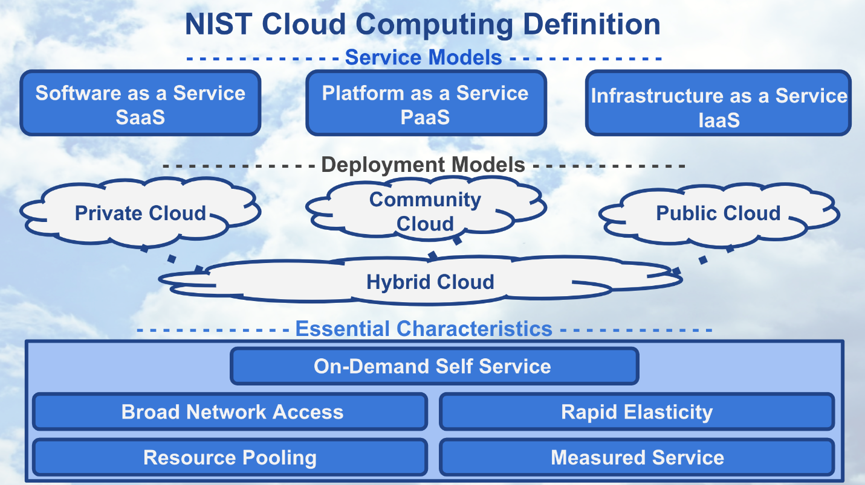

NIST Cloud Computing Definition

In 2011, the National Institute of Standards and Technology (NIST) defined cloud computing using service models, deployment models, and essential characteristics.

While you have already learned that **cloud computing** is thought of as transforming an **IT product**, a flash drive, into a **cloud service**, Google Drive; next we take a more detailed look at cloud computing.

## Service Models of Cloud Computing

Let’s begin by discussing the three **service models** of cloud computing.

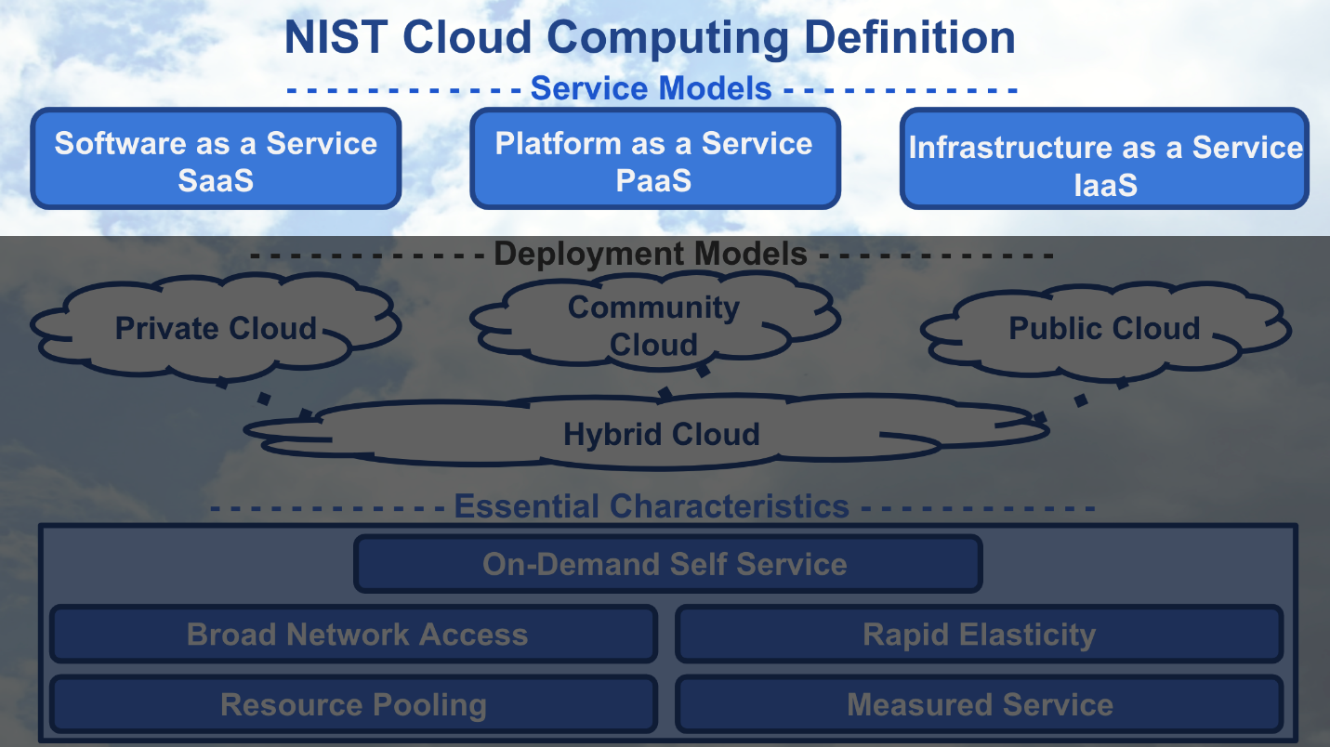

NIST Cloud Computing - Service Models

### Software as a Service

Starting with Software as a Service, SaaS, we’ll use the following graphic to depict the components that compose each of the three service models. The graphic shows whose responsibility it is to create, customize, and maintain the components. The yellow dashed line in the graphic shows with SaaS, the only customer responsibilities are those attributed to a “user” of the service and all other responsibilities are placed upon the cloud provider.

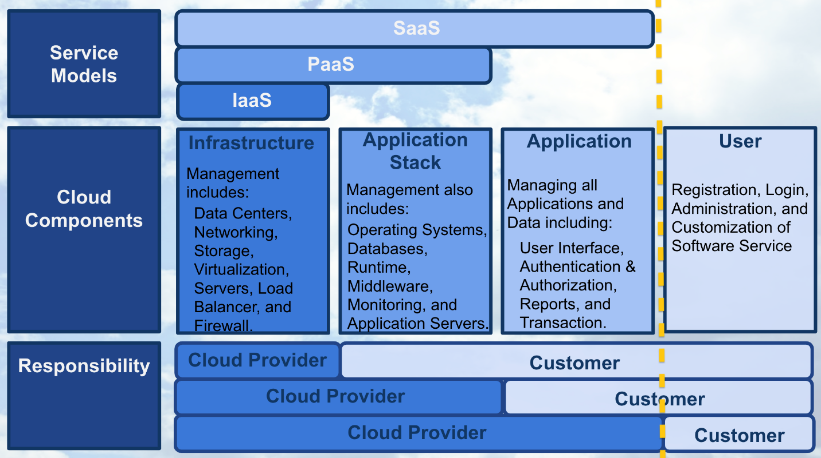

Service Models - SaaS

Software as a product is becoming more rare these days. It used to be that productivity software, like Microsoft Office, was loaded from a physical CD; now you can use applications like Google docs to write, edit, share, and store documents using cloud infrastructure.

Google docs is one example of Software as a Service. Some other examples of SaaS are email applications like gmail and hotmail, and storage applications like iCloud or OneDrive.

With SaaS, a cloud provider’s application that’s running on cloud infrastructure is provided to customers as a service. The customer’s responsibility is only to maintain their user account which typically includes: registration, login, administration, and customization of the software application they’re using as a service.

### Platform as a Service

With Platform as a Service, PaaS, the yellow dashed line demonstrates that the customer gains additional responsibilities that are associated with managing all applications and data, such as including a user interface and dashboard, security, logs, and other features associated to the data and applications.

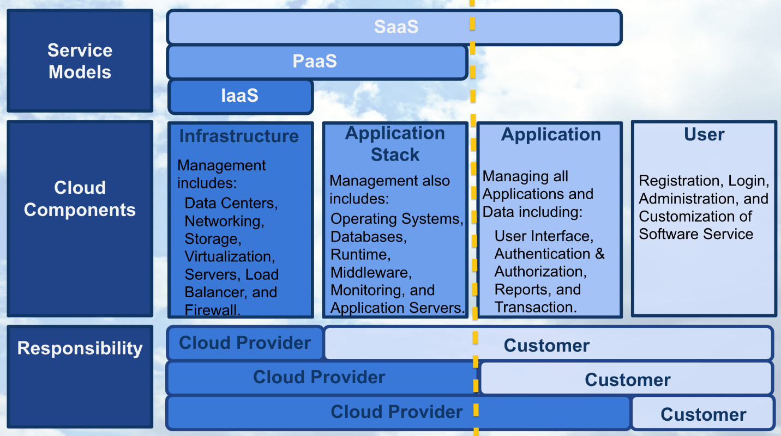

Service Models - PaaS

Some examples of Platform as a Service, are Heroku and Engine Yard. These services allow users to easily build, host, monitor, and scale their applications using their platform. For example, you might use Heroku to build and host an e-commerce website. Google’s App Engine is a similar PaaS for application development and deployment. The creator of “Angry Birds”, Rovio, used Google App Engine to create an online versions of their game.

With PaaS, the service provided to the customer is the ability to deploy customer-created or customer-acquired applications using the cloud provider’s platform. If you are interested in learning more about Rovio’s story using the Platform as a Service, Google App Engine, click on the following [**link**](https://cloud.google.com/customers/rovio/).

### Infrastructure as a Service

With the service model Infrastructure as a Service, IaaS, as shown with the yellow dashed line; the customer has most of the responsibility beyond those associated with running secure data centers and maintaining the hardware and software that enables IaaS.

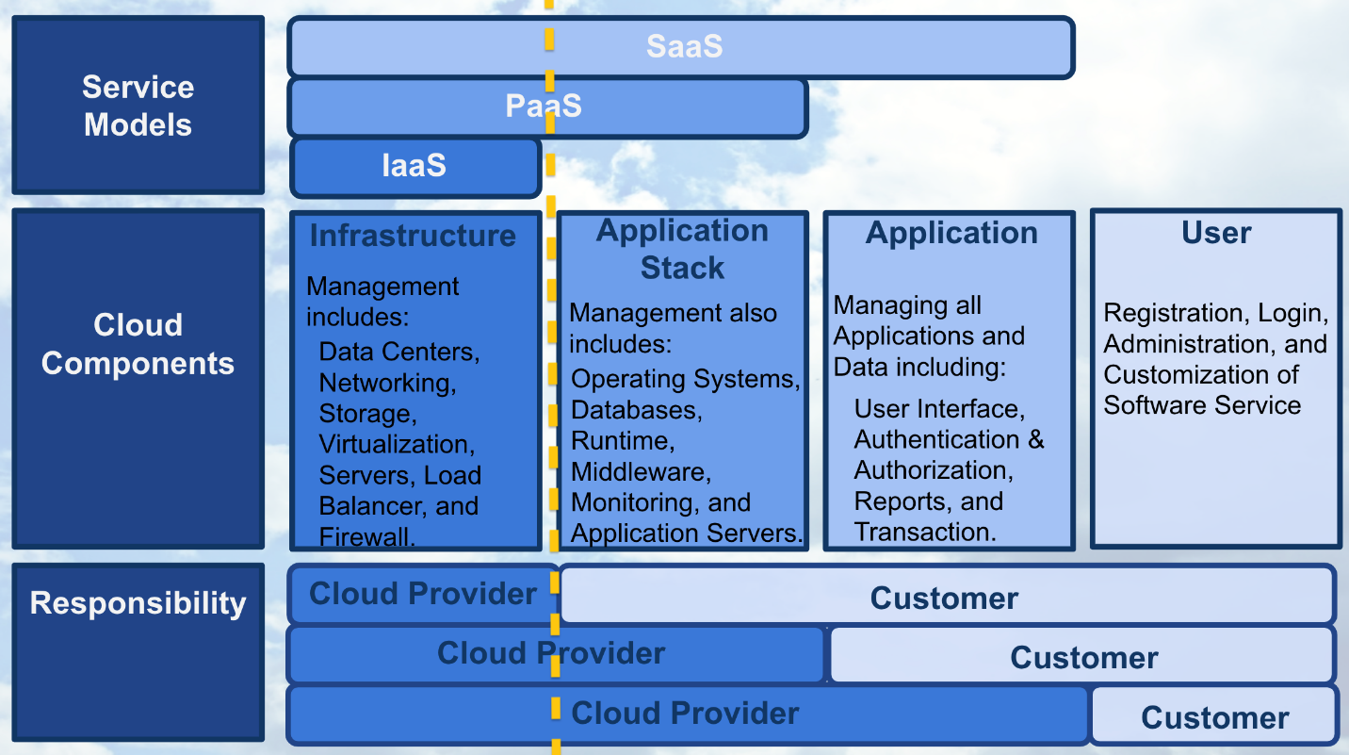

Service Models - IaaS

Some examples of IaaS are Amazon Web Services and Rackspace, which were among the first to offer Infrastructure as a Service that allowed their customers to use virtual machines.

Essentially a virtual machine is similar to a laptop or desktop computer, except it’s offered as a cloud service; requiring the user to login to their virtual machine through an internet connection.

IaaS enables the customer to provisioning computer processing, storage, networks, and other fundamental computing resources, where the consumer can deploy and run software using the provider’s cloud infrastructure.

Although Amazon, Microsoft, and Google all offer IaaS, they also offer other services that fall within the services models Platform and Software "-as-a-service". While you’re likely using “software-as-a-service” for your email, now that you understand the service models, consider expanding your usage of cloud to platform and infrastructure “as-a-service”.

### Service Models Importance

All three service models provide access to greater computing capability and resources for an affordable price.  
With Google App engine you could build the next popular online game, like Angry Birds, or use Amazon’s Virtual Machine service to have access to a more powerful computer instead of upgrading your own.

### QUESTION 1 OF 3

Match the **Cloud Service** with the correct **Service Model**

IaaS

SaaS

PaaS

IaaS

PaaS

SaaS

**CLOUD SERVICE**

**SERVICE MODEL**

SUBMIT

## Deployment Models of Cloud Computing

Let’s discuss the four **deployment models** that define cloud computing.

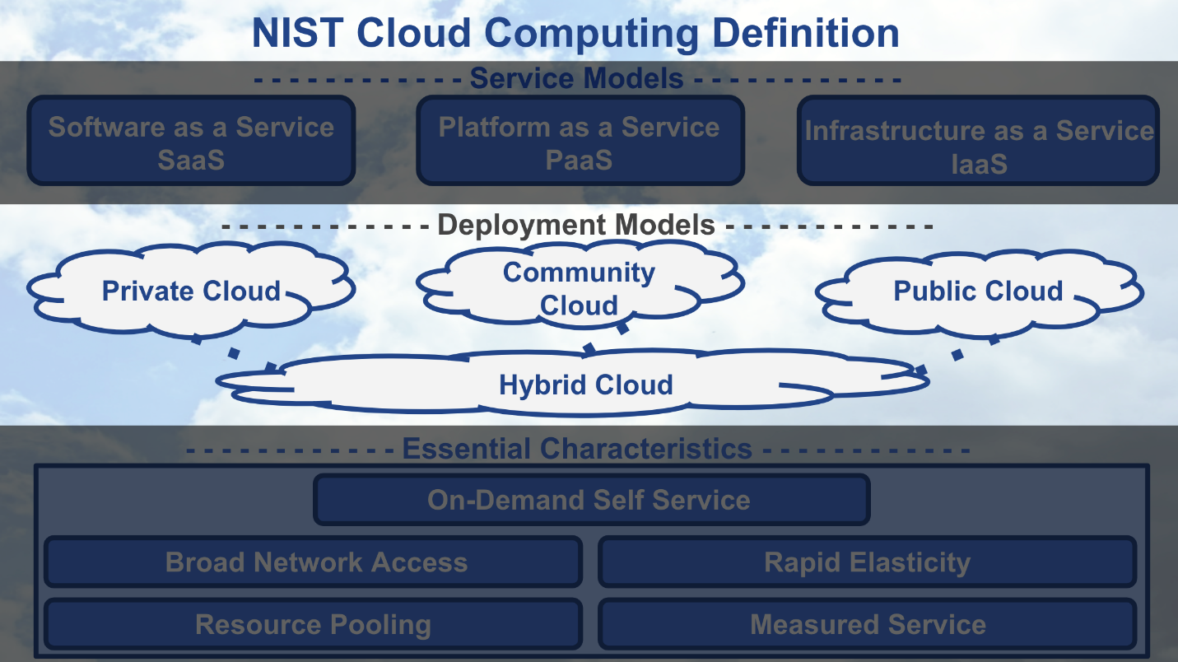

NIST Cloud Computing - Deployment Models

Different levels of security are automatically provided with each deployment model. Understanding deployment models are important in providing the appropriate level of security on the cloud services you use. The primary way to distinguish between different deployment models is by the group that’s provisioning the cloud services. With provisioning, we simply mean the group that’s providing the cloud services for their group’s use.

### Public Cloud

Most cloud deployment models offered by cloud providers, like Amazon Web Service or Google Cloud Platform, are public clouds. Public clouds are provisioned for use by the general public and they are the least secure of the deployment models. Because public clouds are the least secure, most providers allow customers to enable features that provide a “virtual private cloud” to increase the security on their public clouds.

### Community Cloud

Amazon Web Services’ GovCloud is an example of a community cloud. GovCloud customers are limited to US federal government employees, contractors, and agencies that have been granted access. Community clouds are more secure than public clouds because providers limiting access to community members and they isolate computing resources used by the community. A community cloud deployment model is provisioned by a specific community of customers from different organizations that have shared interests, like the US federal government in our GovCloud example. Shared interests may include a shared mission, security requirements, policies, and/or compliance considerations.

### Private and Hybrid Clouds

Private cloud deployment model is provisioned for exclusive use by a single organization. Amazon Web Services offers a Virtual Private Cloud service, but this isn’t considered truly a private cloud unless customers enable additional features that isolate the hardware their cloud services are run on. A private cloud can be physically located on a company’s on-site data center or on a cloud provider’s data center. If the private cloud is provided by a cloud provider, then the private cloud services and infrastructure are always maintained on a private network with hardware and software dedicated solely to the customer’s organization. The hybrid clouds are simply composed of two or three of the different types of deployment model.

### QUESTION 2 OF 3

Most cloud deployment models offered by cloud providers are typically \_\_\_\_\_\_\_\_\_ cloud by default.

* 

Hybrid

* 

Private

* 

Community

* 

Public

SUBMIT

## Essential Characteristics of Cloud Computing

Let’s discuss the five **essential characteristics** that define cloud computing. These characteristics describe the necessary attributes a service must have to be considered “cloud computing”.

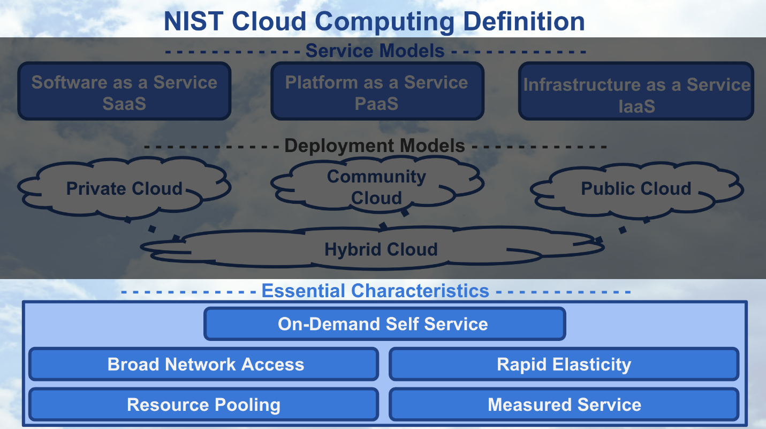

NIST Cloud Computing - Essential Characteristics

As we discuss these essential characteristics, keep in mind our example of uploading a file, like the vacation photos, to a cloud storage service, like [**Google Drive**](https://www.google.com/drive/). These essential characteristics just define aspects of the path your file travels from your laptop to the cloud provider’s data center.

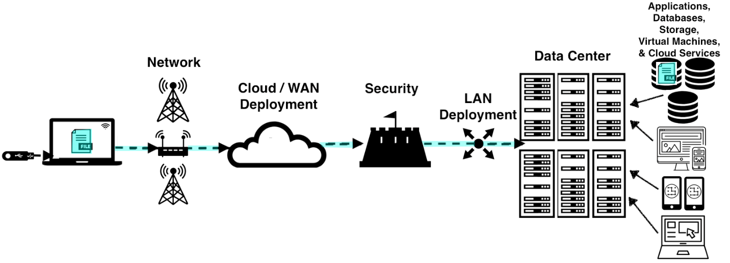

Cloud Computing - Uploading file to a Data Center

### On-Demand Self Service

The essential characteristic on-demand self service means that a customer must be able to automatically provision computing capabilities from the cloud provider without requiring human interaction from the provider. Using our example of cloud storage, on-demand self service is characterized by the ability to log into the cloud storage service and upload, download, or delete the files you have stored within the service at any time without requiring a cloud provider employee to help with these activities.

### Broad Network Access

Broad Network Access means that the computing capabilities are made available over the network accessed through standard mechanisms. Your smartphone, tablet, computer use this broad network access to allow you to work remotely, check social media, reply to an email, and generally access the internet. With our example of cloud storage, Broad Network Access is characterized by the ability to access the files you have stored with the cloud provider using any device that is connected to the internet. Noting that the cloud provider is responsible to ensure the path between the network and the data center.

### Resource Pooling

Resource Pooling allows the cloud provider’s computing capabilities to be pooled to serve multiple customers with different virtual resources that are dynamically assigned and re-assigned based upon customer demand. Using our example of cloud storage, Resource Pooling enables the cloud provider to supply storage services to many customers using their data center to store all their customers’ files. Additionally, the provider’s storage service must be able to handle any customer storing one to many files.

### Rapid Elasticity

Rapid Elasticity enables the cloud provider’s computing capabilities to be elastically provisioned and released to scale rapidly outward and inward proportional to customer demand. This ability to scale rapidly allows the cloud services to appear to have unlimited capabilities that can be used at any time for any quantity of demand. With our example of cloud storage, Rapid Elasticity provides the customer with the ability to store as many or as few files at any time.

### Measured Service

Measured Service allows the cloud provider’s system to automatically control and optimize resource usage by leveraging the system’s metering capability. Specifically, the cloud provider’s resource usage can be monitored, controlled, and reported, which provides the necessary transparency for appropriately billing customers for cloud service usage. Using our example of cloud storage, Measured Service enables the cloud provider to charge a customer appropriately for storage space they are using to store their files.

### QUESTION 3 OF 3

Check **all** characteristics below that are **not** one of the Essential Characteristics.

* 

Resource Reliability

* 

Rapid Elasticity

* 

On-Demand Availability

* 

Rapid Pooling

* 

Self Service

* 

Network Security

* 

Resource Pooling

* 

Measured Adaptability

* 

Broad Network Access

* 

Measured Service

SUBMIT

## Summarizing Cloud Computing



NIST Cloud Computing Definition

You’ve learned what it takes to transform an **IT product** into a **cloud service**. In doing so you learned about the three service models, the four deployment models, and the five essential characteristics of cloud computing. Understanding the definition of cloud computing will help you make appropriate decisions when deploying machine learning models in your workplace.

### References

Below are links and books that provide more detailed information on the topics discussed in this section **above**.

**1.** [**NIST**](https://www.nist.gov/) formal definition of Cloud Computing is found [**here**](https://csrc.nist.gov/publications/detail/sp/800-145/final).

**2.** **Erl**, T., Mahmood, Z., & Puttini R. (2013). Cloud Computing: Concepts, Technology, & Architecture. Upper Saddle River, NJ: Prentice Hall.

* Chapter 4: Discusses Cloud Computing Service Models, Deployment Models, and Essential Characteristics.
* Chapter 5: Discusses some Cloud enabling technologies in more detail.

**3.** **Kavis**, M. (2014). Architecting the Cloud: Design Decisions for Cloud Computing Service Models. Hoboken, NJ: Wiley.

* Chapter 2: Discusses Cloud Computing Service and Deployment Models.
* Chapter 5: Discusses how to choose the right Service Model.
* Chapter 9: Discusses security responsibilities by Service Model.

**4.** [**Amazon Web Services**](https://aws.amazon.com/) (AWS) discusses their definition of [**Cloud Computing**](https://aws.amazon.com/what-is-cloud-computing/), [**Cloud Solutions by Application**](https://aws.amazon.com/solutions/), and [**Service & Deployment Models**](https://aws.amazon.com/types-of-cloud-computing/).

**5.** [**Google Cloud Platform**](https://cloud.google.com/) (GCP) discusses their definition of Cloud Computing and it's benefits [**here**](https://cloud.google.com/what-is-cloud-computing/).

**6.** [**Microsoft Azure**](https://azure.microsoft.com/en-us/) (Azure) discusses their definition of Cloud Computing and it's service and deployment models [**here**](https://azure.microsoft.com/en-us/overview/what-is-cloud-computing/).

# Optional] Cloud Computing Explained

The following content is **optional**, it's provided to give students a greater understanding of cloud computing if they are interested in learning more.

## Cloud Computing Drivers, Benefits, and Risks provided by Cloud Providers and References

The capacity utilization graphic that you will see in this section was originally presented by AWS in 2012 to help explain the benefits of cloud computing. As usage of cloud computing has become more ubiquitous in recent years, cloud providers Amazon, Google, and Microsoft have evolving benefits and improved security within their cloud services (see **3**, **4**, & **5** in **References**). Authors Thomas Erl and Michael Kavis explained in more detail the business drivers, benefits, and risks of cloud computing in their books (see **1** & **2** in **References**). The information found in this section is based upon the materials that we have included in the **References** at the end of this section.

### Recall why businesses decide to use cloud computing

Remember that most of the factors related to choosing cloud computing services, instead of developing on-premise IT resources are related to **time** and **cost**. Below we have an example that explains why startups use cloud services.

Imagine it’s 2010 and you created a photo-sharing application called Instagram. Some challenges you face are you have little funding, few employees, and your application will need to scale to meet customer usage. Ideally, your application needs to scale to meet spikes in demand without having to put limits on application usage or the number of supported users. Because you’re unsure about how popular your application will be, you don’t want to spend funding to prepare for users you may not have. Instead, you want to spend those funds on advertising and extra features to attract more users.

You’ve learned cloud computing provides **pay-as-you-go** service (on-demand self service), that can be available to anyone with **wireless or internet connection** (broad network access), and can **scale up and down rapidly** (rapid elasticity) to meet customer demand easily. These **features** of **cloud computing** make using cloud the obvious choice to launch your photo sharing application.

While it may make sense why a startup like Instagram chose to use cloud services, it may be more perplexing why an established organization would consider incorporating cloud services into their infrastructure. Addressing these questions will provide you with information that will guide decisions you will make when **deploying** machine learning models within your workplace.

### Capacity Utilization Graph

To understand why an established organization would consider incorporating cloud services into their infrastructure, it’s important to understand the **capacity utilization over time graph** below. I’m going to explain this graph in detail to illustrate the business drivers and benefits of cloud computing for both startups and established organizations.



Capacity Utilization Graph

#### Axes

Along the y-axis or vertical axis of this graph is **capacity**. Capacity can be thought of as a number of IT resources like compute capacity, storage, networking, etc. This **capacity** also includes the costs associated with these IT resources. For traditional non-cloud infrastructures, this would include purchase and maintenance of these resources. For cloud infrastructures, this would only include paying for use of these IT services. Along the x-axis or horizontal axis of this graph is **time**. Generally, lines plotted on this graph depict **capacity** across **time**.

#### Lines

For understanding this graph, we are going to return to our Instagram example. Imagine this graph depicts the **capacity** needed for Instagram’s photo-sharing application across a period of a few months. The **black** curvy line depicts the actual customer demand for **capacity** based upon the customers’ usage of the photo-sharing application. The spikes in demand may indicate increased usage by registered Instagram users. The general rise in the **black** curved line over time indicates an increase in the number of registered users of the Instagram application.

The dashed **blue** line depicts the predicted customer demand for **capacity** based upon the predictions Instagram would have made if they would have decided to use traditional non-cloud infrastructure. Instagram would have had to base these predictions on historical data and current trends.

The **blue** step-like line depicts how much **capacity** is provided by the traditional non-cloud infrastructure and hardware. If Instagram would have had decided to not use cloud services, this **blue** step-like line would have been the capacity that Instagram would have provided their customers. In this scenario where Instagram is using traditional infrastructure, they would have needed to build or purchase their own data center and computing resources to provide capacity for their customers.

The **yellow** curvy line depicts how much **capacity** Instagram would provide using cloud infrastructure to meet their customers’ demands for capacity. Notice that using cloud infrastructure will provide automated cloud capacity as a service. This automated cloud capacity enables a company the ability to meet and exceed customer demands, unlike if they had chosen to use traditional non-cloud infrastructure.

### Interpretation of Graph

We explain the graph in detail to demonstrate the benefits of cloud infrastructure. With traditional infrastructure, it takes a considerable amount of time to predict demand, obtain approval for capacity increase, purchase new resources, and install these resources. The graph below depicts this lag of time with how traditional infrastructure is increased to the level of predicted **future** demand. The point select is the time at which they would be able to increase traditional infrastructure again.

If Instagram had decided to use traditional non-cloud infrastructure, they would have needed more capital to make the investment in traditional infrastructure and they would have needed to overestimate customer demand for capacity. This overestimation of customer capacity provides Instagram with the additional time needed to upgrade traditional infrastructure to meet an increasing customer demand.

#### Wasted Capacity

The **cyan** shaded area in this graph below depicts the amount of **wasted capacity** that Instagram would have had with traditional non-cloud infrastructure while they waited for customer demand to meet their capacity. Specifically, the **blue** arrow shows the large costs associated with Instagram attempting to answer the variability in their customer demand for capacity by overestimation of demand using traditional infrastructure.

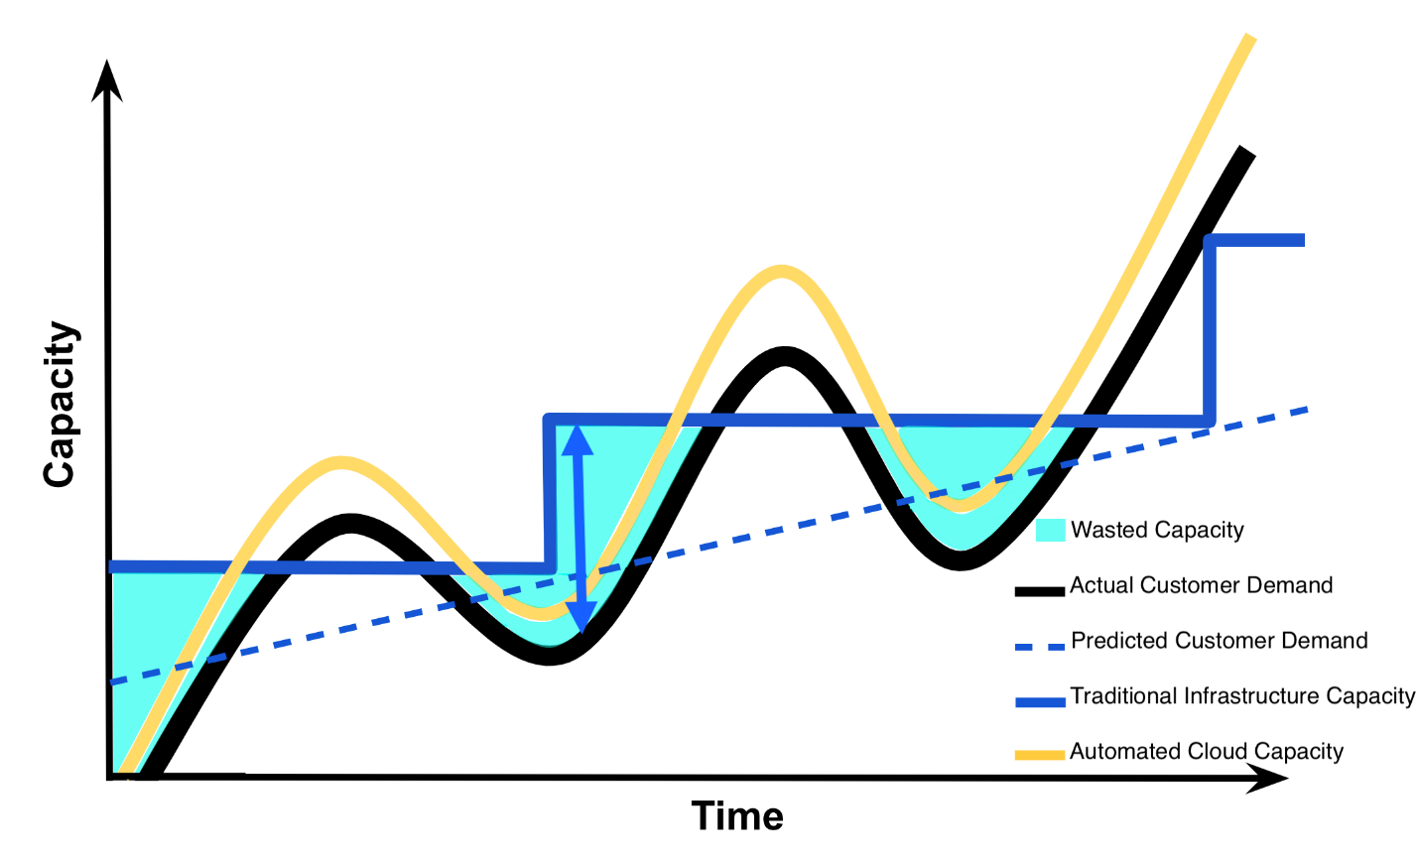

Capacity Utilization Graph - Wasted Capacity

#### Insufficient Capacity

Due to the lag in time needed to upgrade traditional infrastructure, if Instagram failed to overestimate customer demand correctly they run the risk of losing their customers as represented by the **cyan** shaded area in this graph below. This **cyan** shaded area depicts the amount of **insufficient capacity** that Instagram would have had with traditional infrastructure, once customer demand exceeds their capacity. Specifically, the **cyan** shaded areas represent the costs associated with losing customers due to failure to meet customer demand when the demand exceeds capacity provided by traditional infrastructure.

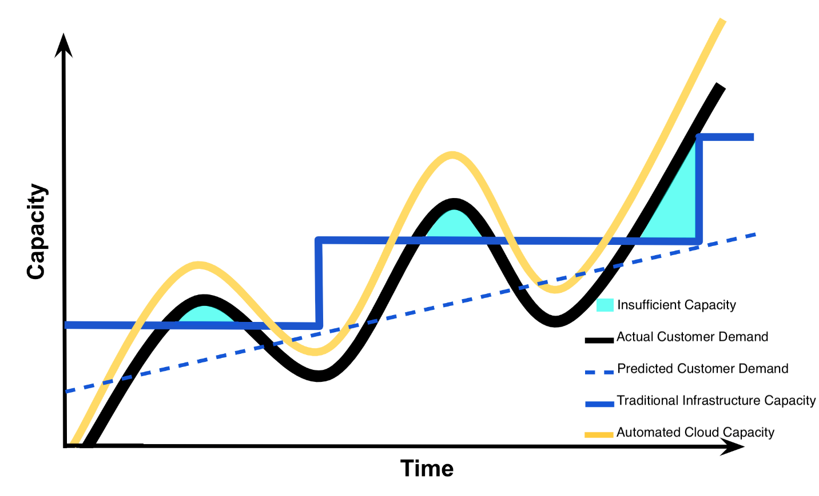

Capacity Utilization Graph - Insufficient Capacity

#### Dynamic Capacity

Understand that with cloud infrastructure, one can set automated triggers that will increase or decrease cloud capacity once a certain level customer demand has been reached. If Instagram uses cloud infrastructure, they will be able to set automatic triggers so that their cloud capacity always exceeds their customer demand for capacity by a small margin as to avoid having insufficient capacity and losing customers. Specifically, the **yellow** arrow in the graph below shows this ability for cloud infrastructure to automatically meet customer demand. The **cyan** shaded area in this graph below depicts the amount of **dynamic capacity** Instagram would need to maintain using cloud infrastructure to guarantee they meet their customers’ demand as to avoid losing customers.

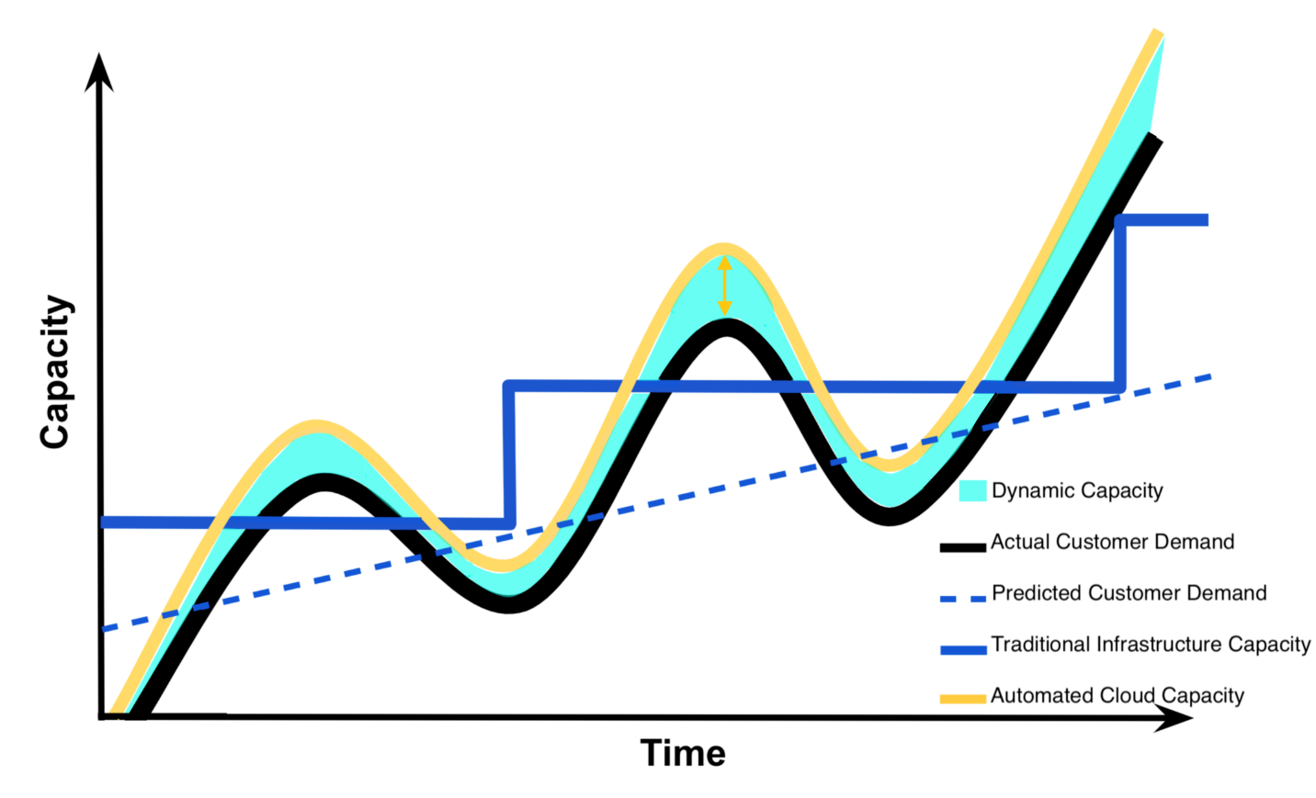

Capacity Utilization Graph - Dynamic Capacity

### Summarizing the Capacity Utilization Graph

Now that we understand this graph, we understand why Instagram or any company would benefit from using cloud infrastructure instead of traditional non-cloud infrastructure with regards to meeting customer demand. This understanding is what drives businesses to consider using cloud computing services.

### QUIZ QUESTION

Select **all** choices below that are included as part of **Capacity** (the y-axis) in the Capacity Utilization Graph.

* 

Time

* 

Costs associated with IT Resources

* 

Compute Capacity

* 

Customer Satisfaction

* 

Automated Demand

* 

Storage (as associated with computers)

SUBMIT

### Benefits of Cloud Computing

The **capacity utilization** graph above was initially used by cloud providers like Amazon to illustrate the **benefits** of cloud computing. Summarized below are the **benefits** of cloud computing which are often what drives businesses to include cloud services in their IT infrastructure [**1**]. These same **benefits** are echoed in those provided by cloud providers Amazon ([**benefits**](https://aws.amazon.com/what-is-cloud-computing/)), Google ([**benefits**](https://cloud.google.com/what-is-cloud-computing/)), and Microsoft ([**benefits**](https://azure.microsoft.com/en-us/overview/what-is-cloud-computing/)). Additionally, these **benefits** are tightly coupled with what **drives** businesses to use cloud computing. In the sections below we explain these benefits and business drivers in greater detail.

#### Benefits

1. Reduced Investments and Proportional Costs (providing cost reduction)
2. Increased Scalability (providing simplified capacity planning)
3. Increased Availability and Reliability (providing organizational agility)

#### Reduced Investments and Proportional Costs

Using cloud computing has the benefit of **reducing investments and having costs proportional** to the usage of cloud services. Recall that cloud computing provides on-demand access to pay-as-you-go cloud computing services; therefore, reducing the necessity to invest in computational resources that will not be used. Additionally, pay-as-you-go services make using cloud resources proportional to their costs. This is illustrated by how automated cloud capacity can meet actual customer demand without wasting capacity nor having insufficient capacity to meet demand.

The automated cloud capacity that always meets customer demand while minimizing wasted capacity, provides cost savings. Specifically, cloud computing provides this direct alignment between cost and performance, the minimization of wasted capacity, and the elimination of insufficient capacity which results in **cost reduction**. Additionally, there are also savings in removing the need to spend company resources on prediction of customer demand. This **cost reduction** that's associated with the benefit of **reducing investments and having proportional costs** is typically considered a business **driver** of cloud computing.

#### Increased Scalability

Cloud computing also provides the benefit of **increased scalability**. This is also demonstrated by cloud capacity meeting customer demand. Using automatic triggers and the rapid elasticity provided by cloud computing enables consumers the ability to ensure that cloud capacity always **exceeds** customer demand by a small margin.

Companies, like Instagram, can utilize these automated features of cloud computing such that they can guarantee they meet their customer demand for capacity while minimizing wasted capacity, and reducing the need to spend company resources to predict customer demand. These automated features of cloud computing simplify **capacity planning** for a business. This simplification of **capacity planning** that's associated with the benefit of **increased scalability** is typically considered a business **driver** of cloud computing.

#### Increased Availability and Reliability

The final benefit is the **increased availability and reliability** provided by cloud computing. While availability and reliability can be provided by traditional infrastructure; these characteristics come natively with the **automatic** on-demand self service, broad network access, and rapid elasticity characteristics of cloud computing. Additionally, cloud providers provide guarantees associated with availability and reliability of their services in their service-level agreement, SLA.

This **increased availability and reliability** as depicted by automated cloud capacity (**yellow** curvy line in the capacity utilization graph) illustrates how companies that use cloud computing can better adapt and evolve to respond to changes in customer demand as compared to traditional infrastructure (**blue** step-like line in the capacity utilization graph). This **increased availability and reliability** provides a company with **organizational agility** that's typically considered a business **driver** of cloud computing.

## Risks of Cloud Computing

To understand the **risks** of cloud computing, recall the essential characteristics that compose the definition of cloud computing. Below we have also summarized he **risks** associated with cloud computing [**1**]. Cloud providers don't typically highlight the risks assumed when using their cloud services as they do with the benefits, but cloud providers like: Amazon ([**security**](https://aws.amazon.com/security/introduction-to-cloud-security/)), Google ([**security**](https://cloud.google.com/security/data-safety/)), and Microsoft ([**security**](https://www.microsoft.com/en-us/TrustCenter/CloudServices/Azure/default.aspx)) often provide details on security of their cloud services.

It's up to the cloud user to understand the compliance and legal issues associated with housing data within a cloud provider's data center instead of on-premise. The service level agreements (SLA) provided for a cloud service often highlight security responsibilities of the cloud provider and those assumed by the cloud user. Below you will find the risks of cloud computing described in greater detail.

#### Risks

1. (Potential) Increase in Security Vulnerabilities
2. Reduced Operational Governance Control (over cloud resources)
3. Limited Portability Between Cloud Providers
4. Multi-regional Compliance and Legal Issues

#### Increased Security Vulnerabilities

Consider that to have on-demand self service with broad network access and resource pooling, one needs to access cloud services through the internet. Additionally, when cloud services utilize resource pooling, a customer might be using a **shared** cloud resource instead of a physically isolated resource. Cloud computing can have the **risk** of **increased security vulnerabilities**; as compared to traditional infrastructure, which typically involves a direct connection to on-premise infrastructure with isolated resources.

#### Reduced Operational Governance Control

Cloud computing has the **risk** of **reduced operational governance control** due to the risks associated with how the cloud providers operate their infrastructure and that they required external connections for communication between provider and customer. For example, a disreputable cloud provider could make guarantees in their cloud services’ service-level agreements that they fail to honor; therefore, making their customers **unknowingly** more vulnerable. Additionally, the cloud providers’ data centers might be located physically located much further from their customers than if their customer had opted to use traditional infrastructure. This increased physical distance could cause variable latency and bandwidth issues.

#### Limited Portability Between Cloud Providers

Another **risk** of cloud computing is the **limited portability between cloud providers**. The lack of an established industry standard could lead to customer **dependency** on particular cloud providers. Think about how difficult it is to share photos from a Photo Stream with those who don’t have iPhones, iPads, or other Apple devices. It’s **not** impossible, but it isn’t simple and those without an Apple device don’t get the same functionality as those that have an Apple device. Similar can be said regarding most cloud platforms, it’s **not** impossible to move between cloud providers, but the transfer of data and code might not be seamless and certain providers may offer services of features that aren’t offered by other providers.

#### Multiregional Compliance and Legal Issues

The final **risk** of cloud computing is the **multiregional compliance and legal issues** that may result from using cloud computing. Specifically, a cloud provider establishes their data centers in affordable and geographically convenient locations. The physical location of data centers can cause legal concerns connected to industry or government regulations that specify data privacy and storage policy. Additionally, there could be legal issues associated to accessibility and disclosure of data based upon the country’s laws where the data center is located. For example, consider how the General Data Protection Regulation of the European Union is a much stronger data protection and privacy regulationthan offered by the United States; therefore, US businesses must adhere to these stronger protections if they operate within the countries that are members of the European Union.

# Cloud Computing Guidelines and Examples

## Cloud Computing Guidelines

#### Considerations for Startups

Cloud computing solutions work **best** for **startups** that can use cloud infrastructure instead of building their own from scratch. Being able to use cloud infrastructure typically means that a **startup**:

* Has no real infrastructure overhead costs due to the pay-as-you-go and on-demand access that cloud services provide.
* Requires fewer staff and costs less to build and maintain their software product or application due to the ease of use and quick startup associated with cloud services as compared to traditional infrastructure.
* Has greater ability to scale and meet customer demand for capability more efficiently (less cost, less wasted capacity or insufficient capacity - refer to Capacity Utilization Curve below).
* Can get their software product or application to market much more quickly.



Capacity Utilization Graph

#### Considerations for Established Organizations

For **established** **enterprises** and **organizations** with large amounts of infrastructure and legacy architectures already in use, introducing cloud services into their traditional infrastructure may not make sense. Primarily because some of the efficiencies above do not hold true when there is existing computing infrastructure, some of the legacy architectures might not be able to be integrated with cloud services, some of the risks of cloud computing (security, governance, compliance) might outweigh expected the benefits of using cloud computing for the established organization, company culture might not be accepting of replacing traditional infrastructure with cloud, and company employees may lack the skill set to use cloud computing.

## Cloud Computing Successes

Below we have provided examples of four companies (startup and established organizations) that embraced cloud computing to become successful.

#### Instagram

In October 2010, the photo-sharing application called **Instagram** launched and:

* within 1 day, it had 25,000 users
* within 3 months, it had 1 million users
* within 1 and ½ years, it had close to 30 million users [**2**]

Facebook purchased **Instagram** for an estimated $1 billion in April 2012 [**2**]. By September 2012, **Instagram** had 100 million users, just shy of two years after their initial launch [**2**]. At the time of **Instagram’s** purchase company consisted of 13 employees and over 100 servers running in Amazon’s Web Service, AWS, to support 30 million users [**2**].

**Instagram** had the luxury of starting from scratch and architecting for the cloud to start. To learn more about how **Instagram** migrated to AWS’s Virtual Private Cloud, see [**here**](https://instagram-engineering.com/migrating-from-aws-to-aws-f4b16a65e13c) - 10 minute read. To learn more about how **Instagram** migrated from AWS data centers to Facebook data centers, see [**here**](http://instagram-engineering.tumblr.com/post/89992572022/migrating-aws-fb) - 4 minute read.

#### Netflix

**Netflix** is a pioneer in the online video streaming industry. In 2009, 100% of all streaming traffic was run through **Netflix’s** own data center [**2**]. By end of 2010, most of all that traffic was run through AWS data centers, with a goal of 95% of **all** services run through AWS [**2**]. **Netflix** made a business decision to move to the Cloud, they hired and trained an incredible engineering team to continue to be pioneers in cloud computing.

To learn more about how **Netflix** use of AWS, see [**here**](https://aws.amazon.com/solutions/case-studies/netflix/) - two videos 7 minutes total. To learn more about the open source software that **Netflix** developed to run on AWS look [**here**](https://netflix.github.io/).

#### HSBC Bank

**HSBC** is a 150 year old international organization that recently migrated to the Google Cloud Platform. The following [**video link**](https://www.youtube.com/embed/j_K1YoMHpbk?start=3578&end=4311) is a 12 minute video from the Google Cloud Next 2017 Day 1 Keynote address. The moderator is Tariq Shaukat, President for Customer facing Operations at Google Cloud; he introduces Darryl West, the Global Chief Information Officer at **HSBC**. Darryl West explains **HSBC’s** partnership with Google and their migration to the cloud.

#### eBay

**eBay**, the company that facilitates auction style online sales, recently migrated to the Google Cloud Platform. The following [**video link**](https://www.youtube.com/embed/j_K1YoMHpbk?start=4547&end=4989) is a 7 and ½ video from the Google Cloud Next 2017 Day 1 Keynote address. The moderator is Diane Greene, a SVP at Google Cloud; she is speaking with RJ Pittman, the Chief Product Office at **eBay**. He describes **eBay’s** migration to the cloud.

# Machine Learning Workflow and Cloud Computing

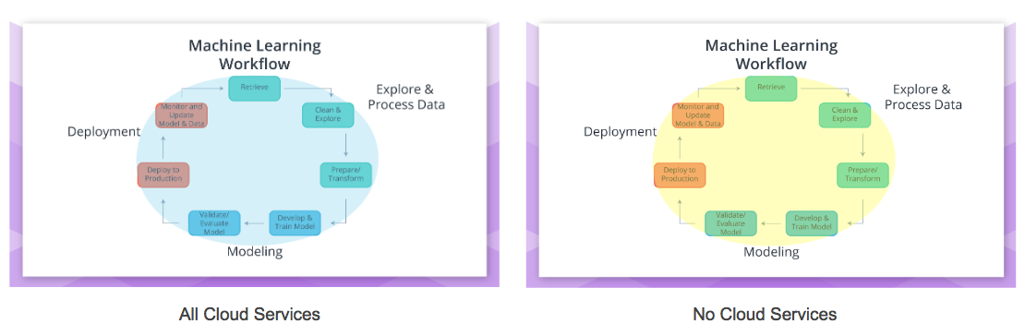

## Cloud Computing within the Machine Learning Workflow

#### Deciding the Amount of Cloud to include within the Workflow

Thinking back on the Machine Learning Workflow, one might wonder how this workflow fits within cloud computing services. Cloud computing services can be used for **all** parts of the Machine Learning workflow (**blue** enclosed figure) to none of the parts (**yellow** enclosed figure) of the Machine Learning workflow.

Guiding how much or how little of the machine learning workflow is using cloud computing services are an organization's:

* Existing infrastructure
* Vulnerability to the risks of cloud computing

Your workplace may have security concerns, concerns regarding operational governance of the cloud services, and/or compliance and legal concerns regarding the use of cloud services. Additionally, your workplace may also have already on-premise infrastructure that supports the machine learning workflow; therefore, making the use of cloud services an unnecessary expenditure.

#### Typical Scenarios

Cloud services like Amazon’s SageMaker can be used for **all** parts of the Machine Learning Workflow (**blue** enclosed figure ***above***); and with subsequent lessons you will be using Amazon's SageMaker in this all cloud scenario. Some users of SageMaker may decide to Explore and Process Data using on-premise (non-cloud) resources (**yellow** enclosing the "Explore & Process Data" **below**).

Cloud services like Google’s Cloud ML Engine are meant to be used primarily for Modeling and Deployment. It’s up to the user of Google's ML Engine if they would like to use on-premise (non-cloud) resources, Google’s Cloud Dataflow service, or other cloud services for the Explore and Process Data part of the Machine Learning Workflow.

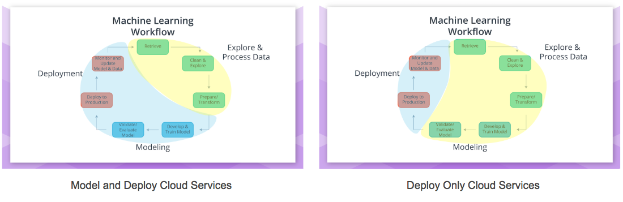

Another common way to incorporate cloud into the machine learning workflow is to only use cloud computing services for Deployment (**blue** enclosing the "Deployment" **above**). This might be a common strategy for organizations that are concerned about protecting the privacy of the data they used to create the model that was deployed. Additionally, organizations might host their web application or software application on cloud assets to allow for greater scalability and availability for less cost as offered by cloud services.

Note that the machine learning workflow and underlying algorithms discussed in the Deployment will be similar regardless if using on-premise or cloud resources.

### References

Below are links and books that provide more detailed information on the topics discussed in this section **above**.

**1.** **Erl**, T., Mahmood, Z., & Puttini R. (2013). Cloud Computing: Concepts, Technology, & Architecture. Upper Saddle River, NJ: Prentice Hall.

* Chapter 3: Discusses Business Drivers, Benefits, and Risks of Cloud Computing.

**2.** **Kavis**, M. (2014). Architecting the Cloud: Design Decisions for Cloud Computing Service Models. Hoboken, NJ: Wiley.

* Chapter 1: Cloud Computing define and early examples of cloud computing that highlight the benefits.
* Chapter 3: Cloud Computing worst practices are discussed to highlight both risks and benefits of cloud computing.
* Chapter 9: Discusses security responsibilities by Service Model.

**3.** [**Amazon Web Services**](https://aws.amazon.com/) (AWS) discusses some benefits of Cloud Computing [**here**](https://aws.amazon.com/what-is-cloud-computing/) and security [**here**](https://aws.amazon.com/what-is-aws/) and [**here**](https://aws.amazon.com/security/introduction-to-cloud-security/).

**4.** [**Google Cloud Platform**](https://cloud.google.com/) (GCP) discusses some benefits of Cloud Computing [**here**](https://cloud.google.com/what-is-cloud-computing/) and security [**here**](https://cloud.google.com/security/data-safety/).

**5.** [**Microsoft Azure**](https://azure.microsoft.com/en-us/) (Azure) discusses their some benefits of Cloud Computing [**here**](https://azure.microsoft.com/en-us/overview/what-is-cloud-computing/) and security [**here**](https://www.microsoft.com/en-us/trustcenter/cloudservices/azure)